ED Activities Report 2019-2020

21.08.2019

As a part Observance of world entrepreneurship day ED club in association with PG Department of Commerce organised an entrepreneurship awareness class on 21 August 2019 at MSK Hall in MES Ponnani College. Smt Siji Verghese (HOD, Department of Commerce) delivered the welcome speech,. Dr Zubair A A (Principal in charge,MES Ponnani College) presided over the function . This Programme inaugurated and topic presented by Smt Smitha P( Assistant District Industries Officer, Ponnani) . Felicitation given by Dr Sina A R( Secretary staff club) .Vote of thanks given by Shalalas P M ,executive member of ED club.This programme became grant success.

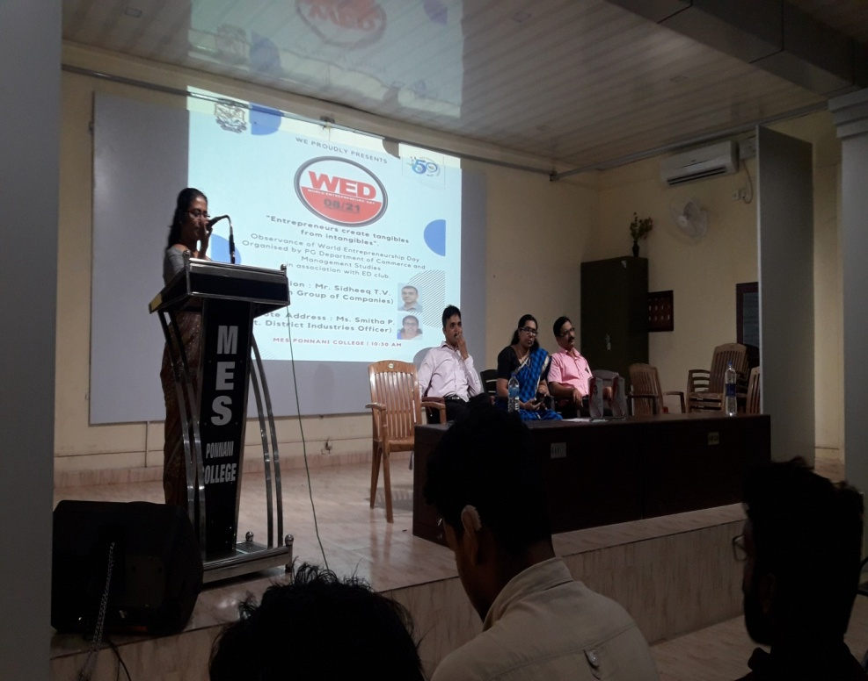

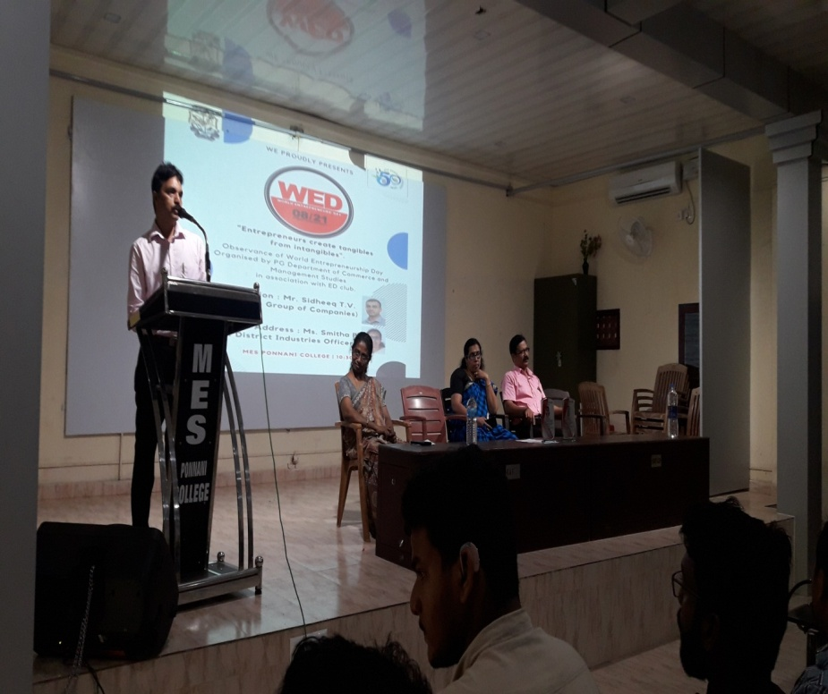

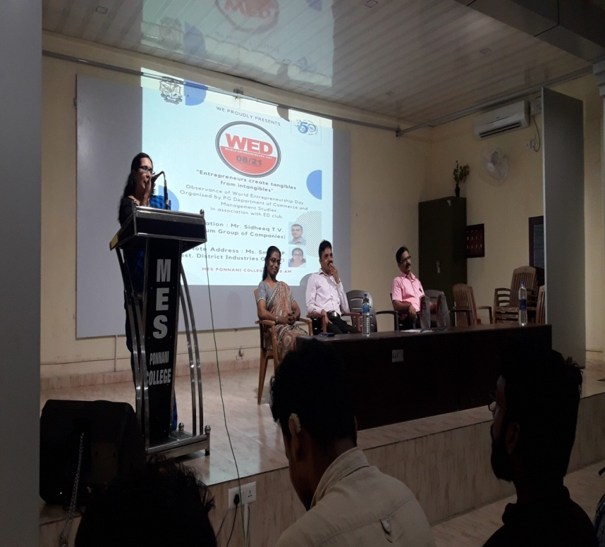

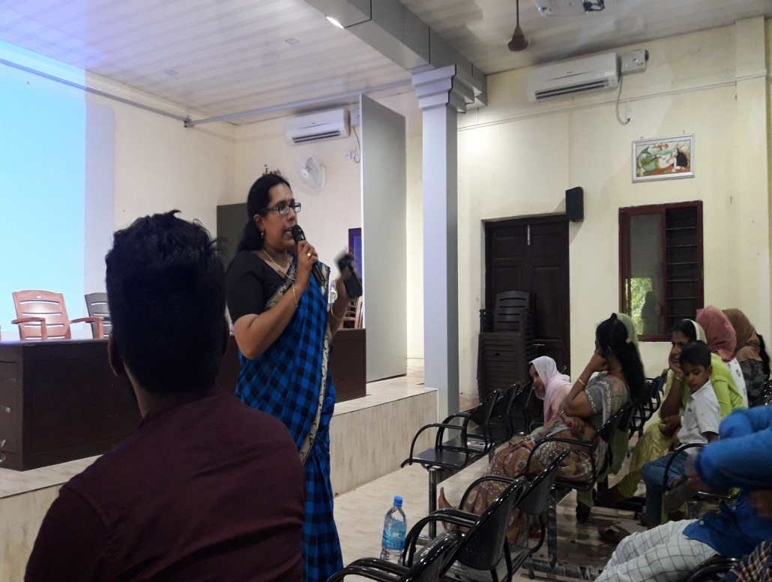

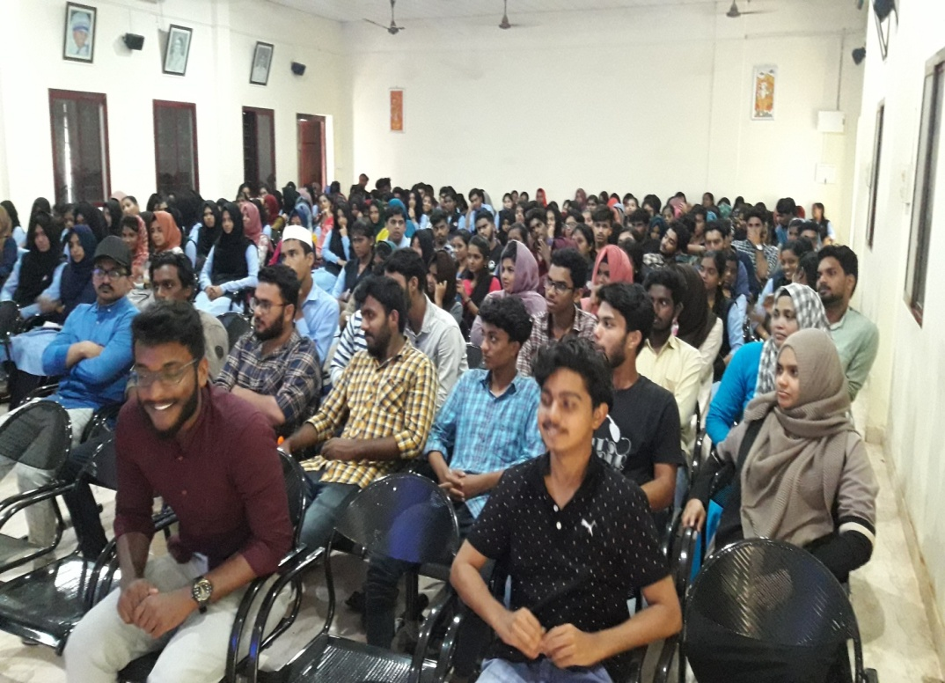

28_09_19

Ed members Shahul hameed,Sharoof T K(2nd Bcom) ,Saranya T V &Muhammed Shibili(3rd B com) along with Rafeeque M T(Assistant Professor Dpt of commerce) participated and presented the project in the programme named” IDEA FAIR” organised by Malabar Chamber of Commerce, Malappuram at Eranad Knowledge City,Manjeri . Around 25 college ED members partipated that program. They got good experience in presenting that project.

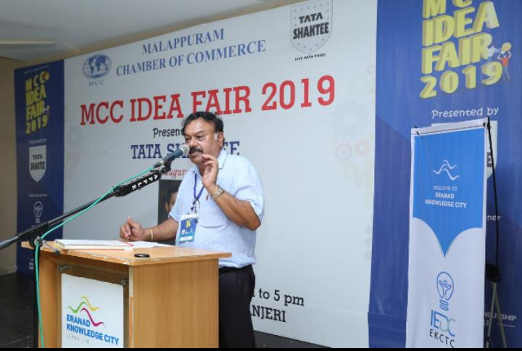

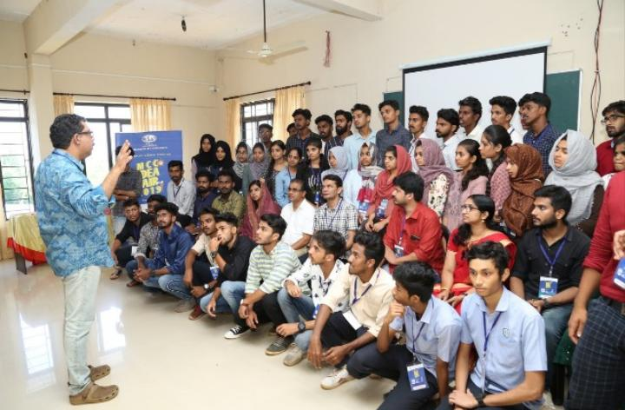

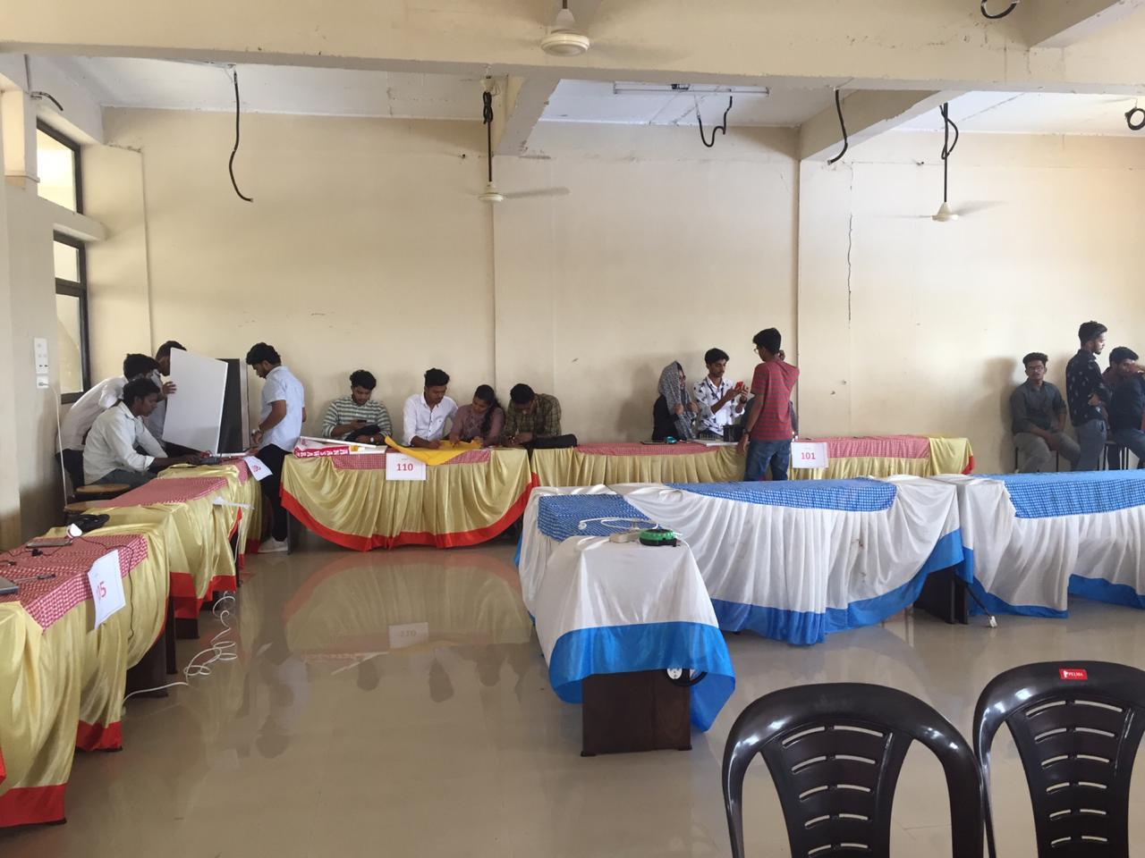

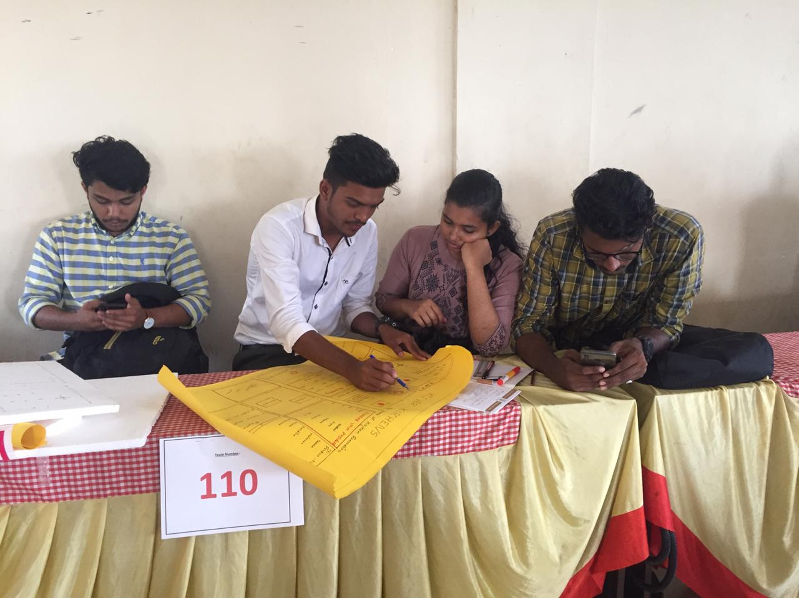

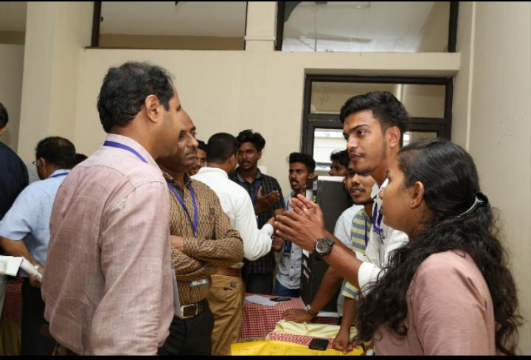

16/10/2019

Malappuram District industrial centre organised an entrepreneurs investment meet at conference hall DIC,Civil Station Ponnani. Sri Mohammed kunhi C P (Counsellor, Ponnani Muncipality)inaugurated the function. Around 60 entrepreneurs in different locality in ponnani taluk participated in the Program. The first session handled by Industrial officer ,Thrissur.The Topic was how to give the project application. Smitha P Asistant district industrial officer ,Ponnani handled the second session. The topic financial schemes under the ssi units. Sri kunhiraman he lead bank manager , canara bank malappuram handled the last session . The entreprenurs wisely interact the in all sessions. Smt.muneera, ed club coordinator,MES College ,Ponnani participated the program. She have good experience in the session.

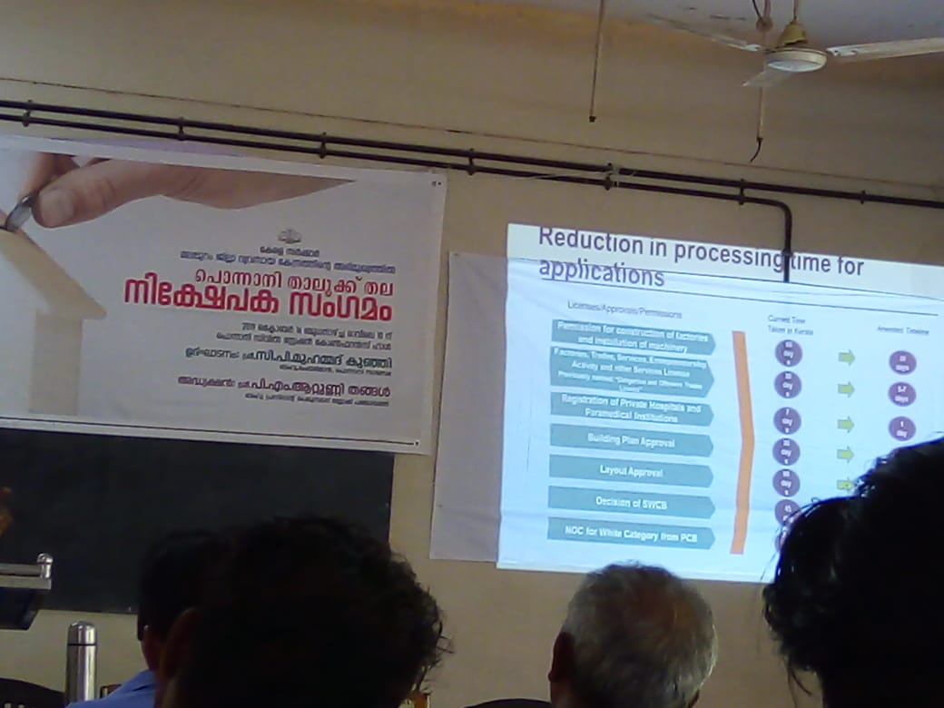

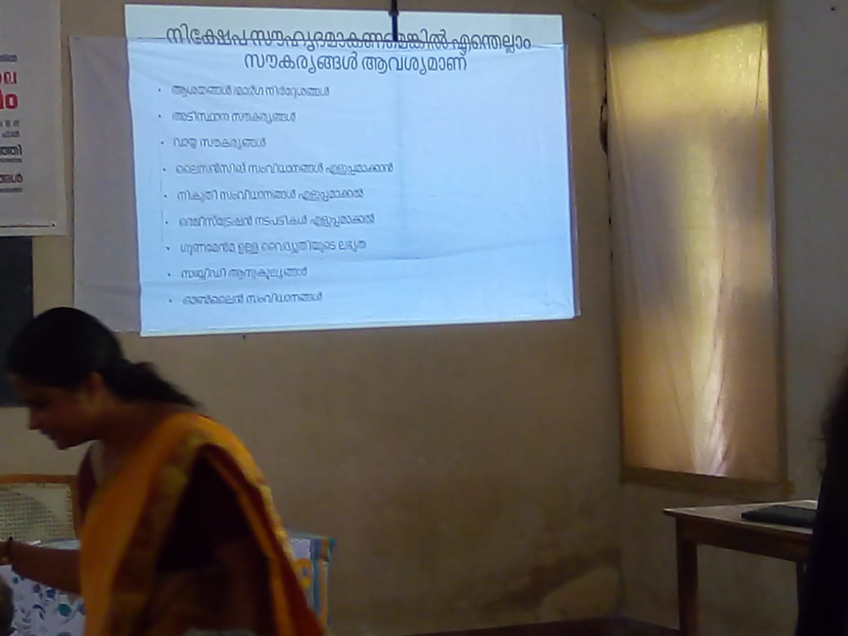

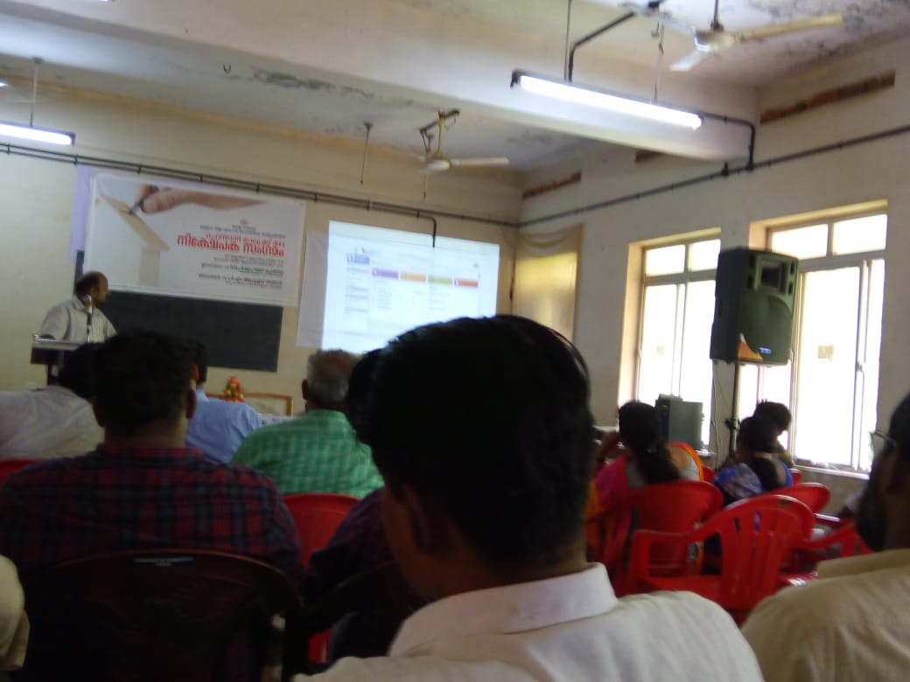

WEDP

In November third week programme coordinator Sri Dileep kumar k (Kitco,Cochin) discussed the matter organizing WEDP with the Principal and ED Club Coordinator, MES Ponnani College . After that he invite applications given advertisement through 4 news papers in the malappuram edition for starting WEDP in ponnani college. On 2nd December 2019 held interview at mes ponnani college for taking admission to WEDP duration 4 weeks. In interview 8 msc physics students and 18 other students and alumnee were admitted for this programme.

On 9th December 2019 held inaugural function of WEDP at 1.30 pm ,Conference hall. In this function welcome speech delivered by smt.muneera K coordinator ED Club. Principal Captain M N muhammed koya presided over the function. Mr Muhammed Rasheed , Secretary MES Ponnani College inaugurated the function. Key note address delivered by Sri Dileep kumar K ed trainer,Kitco cochin. Felicitations given by Prof Siji verghese, HOD ,Dept of Commerce,Dr Sina ,Secretary,Staff club and Vice chairman, union ,mes ponnani college.Vote of thanks was delivered by Prof Jahfar A

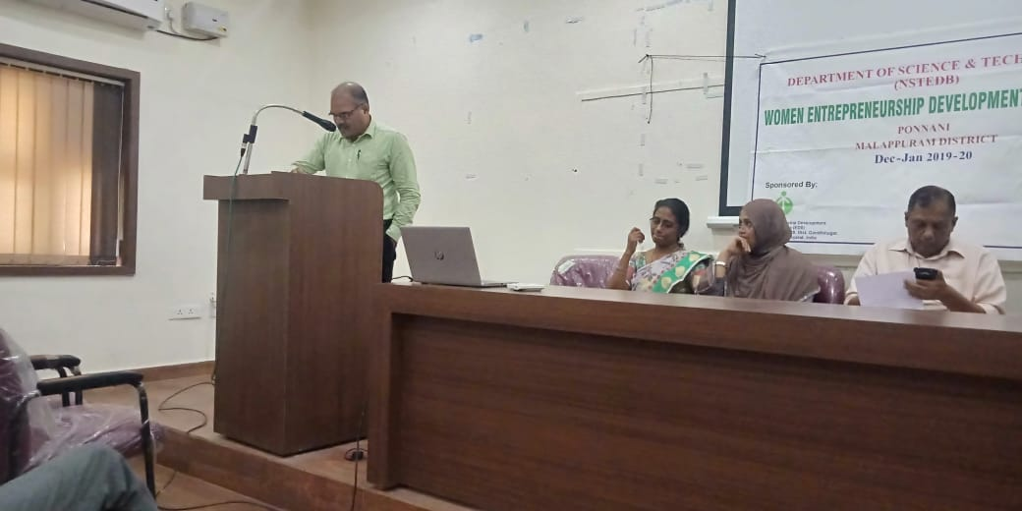

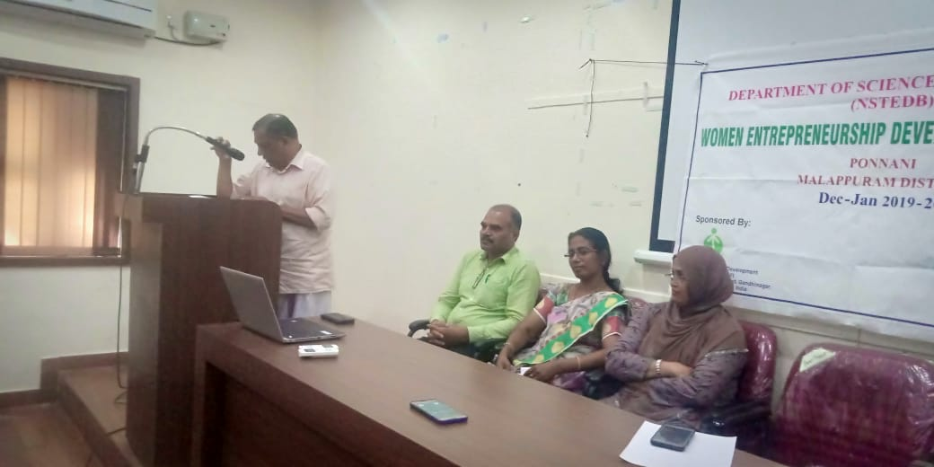

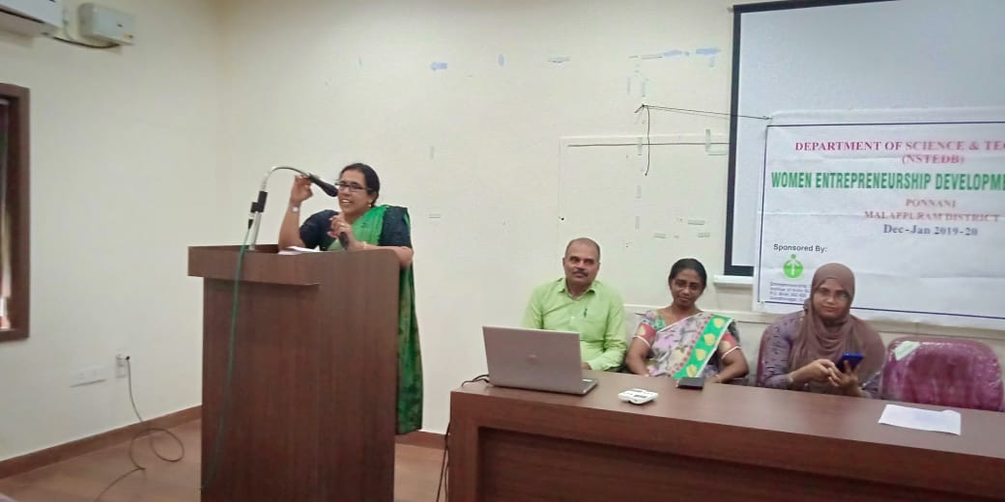

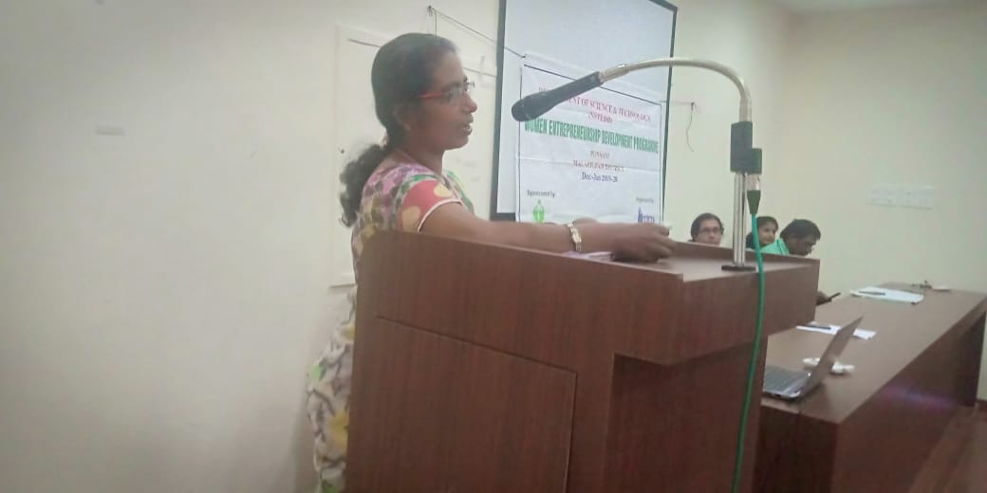

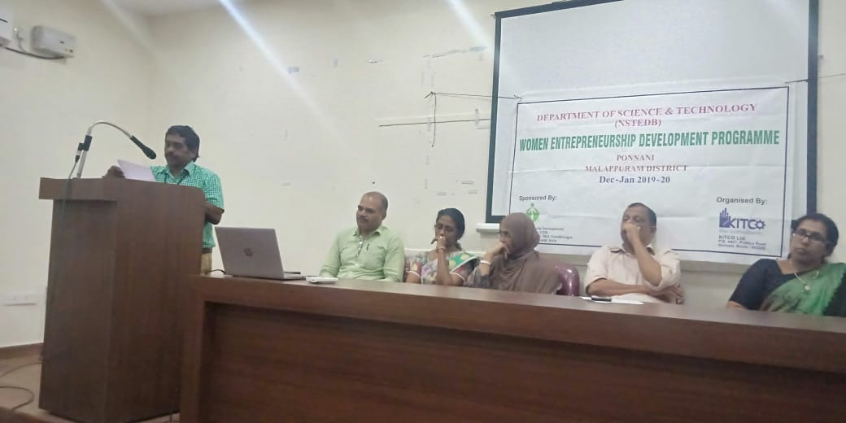

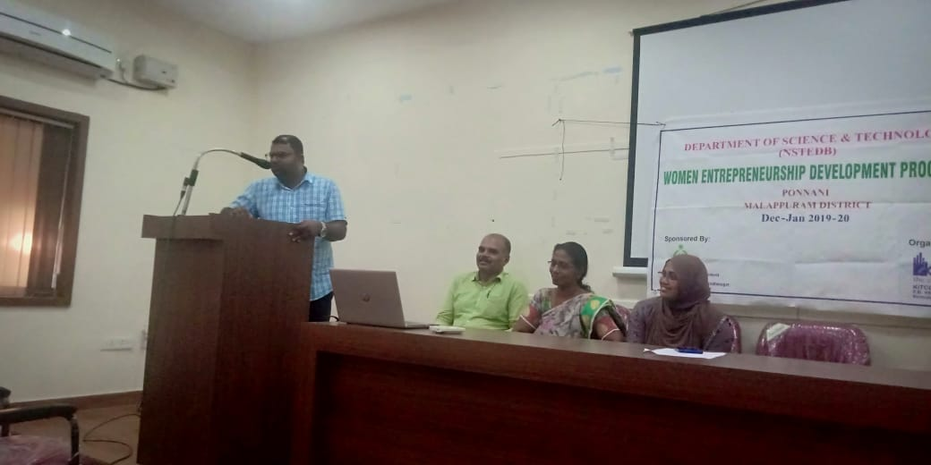

9-12-19

After inaugural function of wedp Sri Dileep kumar , a motivational trainer(Kitco,cochin) gave a motivation class for 2 hours with power point. The topic was cooperation, communication and planning for the start up. H e explained the sources of motivation through various examples

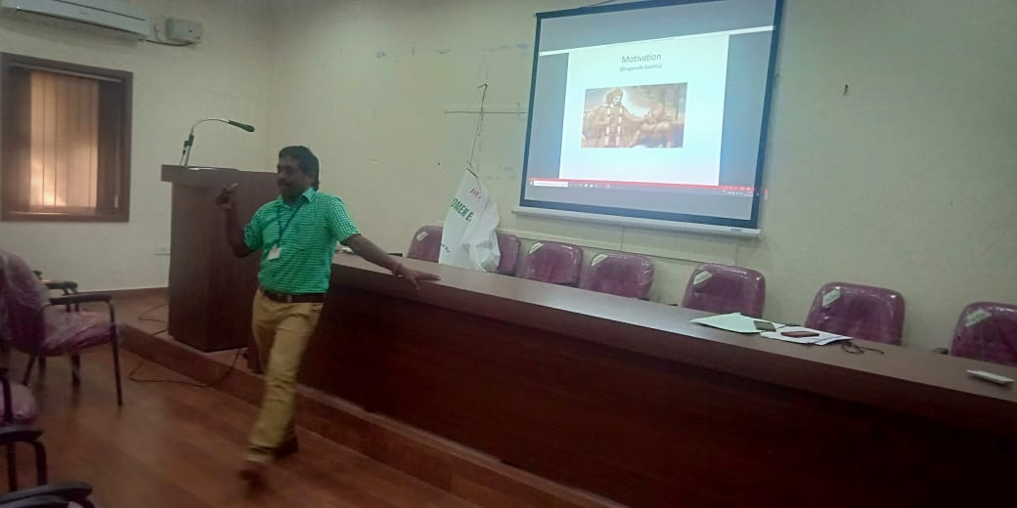.

10-12-19

On 10th Dec 2019 Sri Dileep kumar K started a motivation class in !st bcom room with an activity programme to explain the hidden potential from us. Also conducted some group activities to bring out the team member qualities,sportsmanship,individual idea sharing and preplanning. He gave multiple activities by dividing us into variousgroups to understand think out ofproblem in every situation.

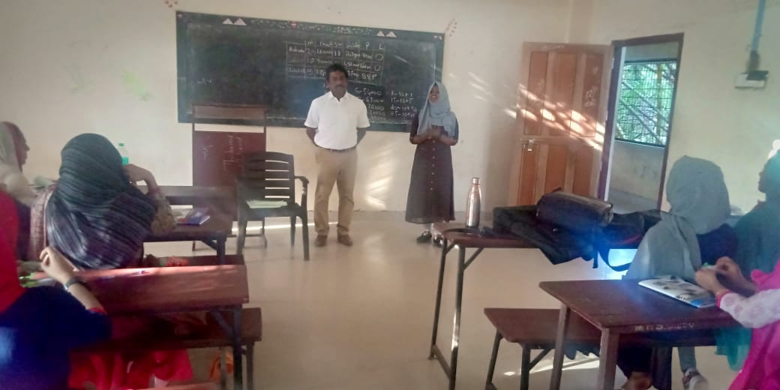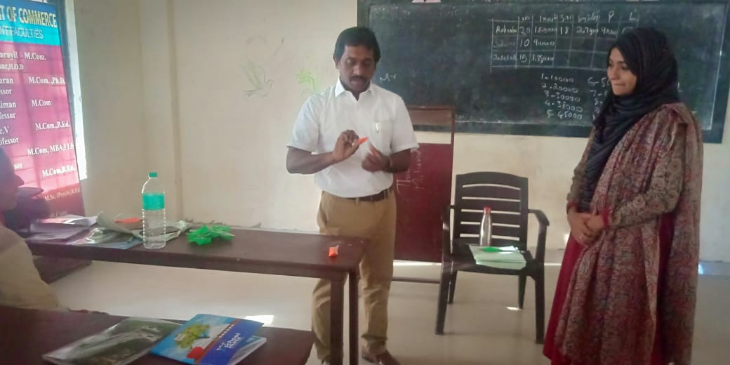

11.12.2019

On 11th December 2019, class was taken by Mr. Anoop R(Proprietor,Prominent , Kozhikode) He explained sales tax registration procedure,SSI ,Trade name registration in detail. He described how he developed a company of his own from the beginning to the present situation

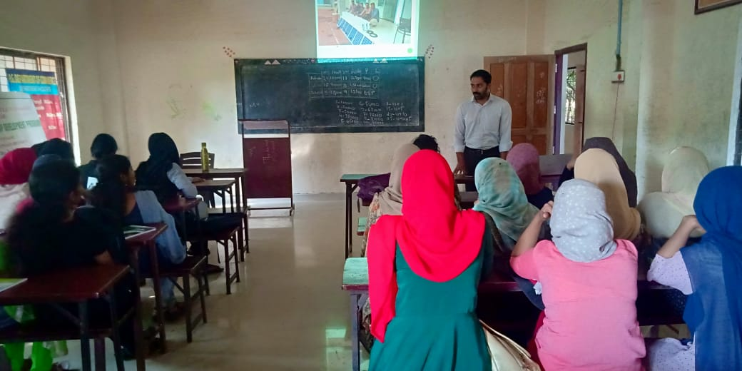

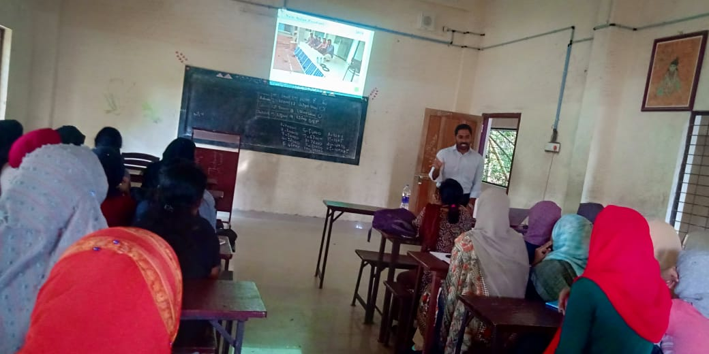

12.12.2019

On 12th December 2019, class was taken by Smt. Smitha P(District industries officer ,DIC Ponnani)

She explaine various opportunities And procedure in DIC. She explained the steps before applying licence, registration and also financial schemes for msmes and SSI.

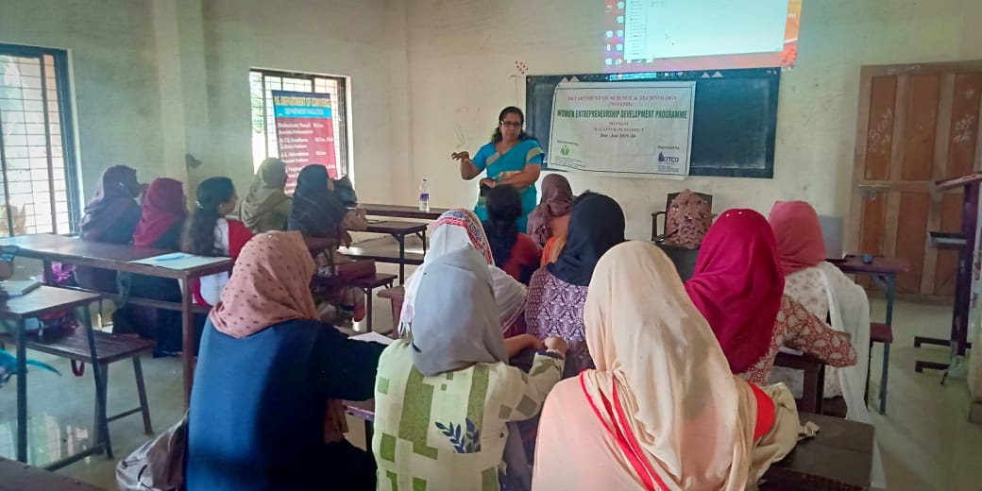

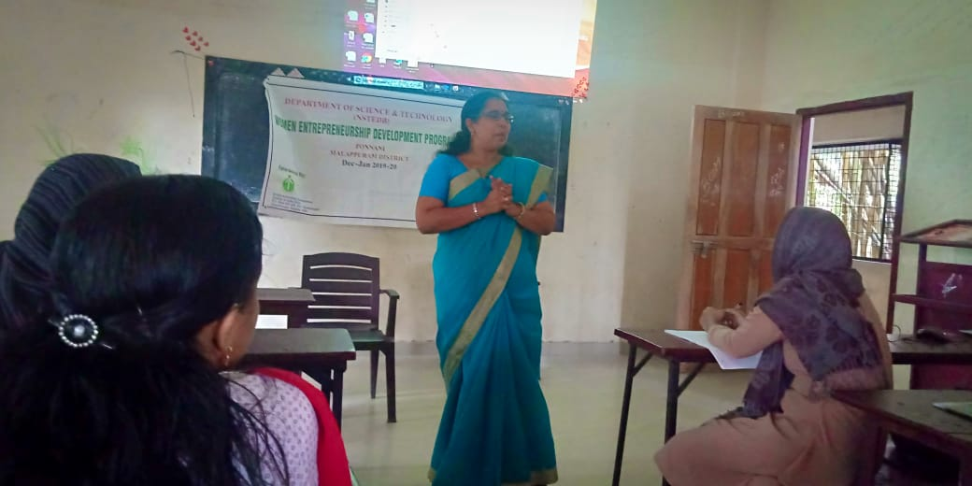

13.12.2019

On 13th December 2019, the class was taken by Mrs. Safna(MEC,Kudumbasree,MPM) about communication and woman empowerment. She explained effective communication,its types, process of communication in detail. It nwaas nice experience.

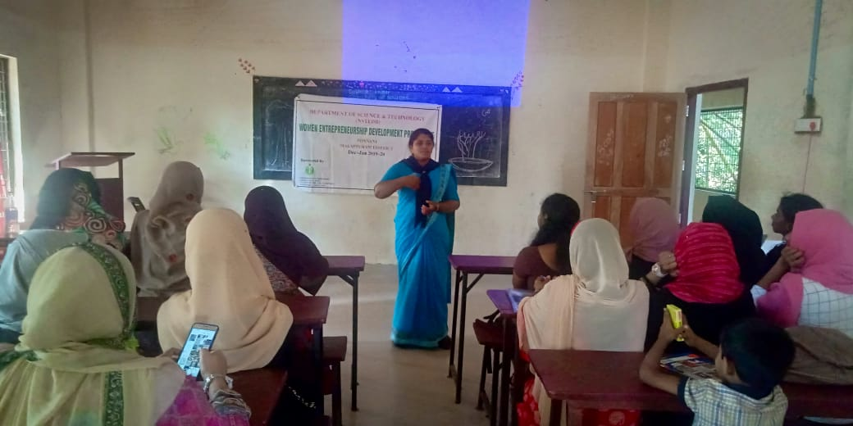

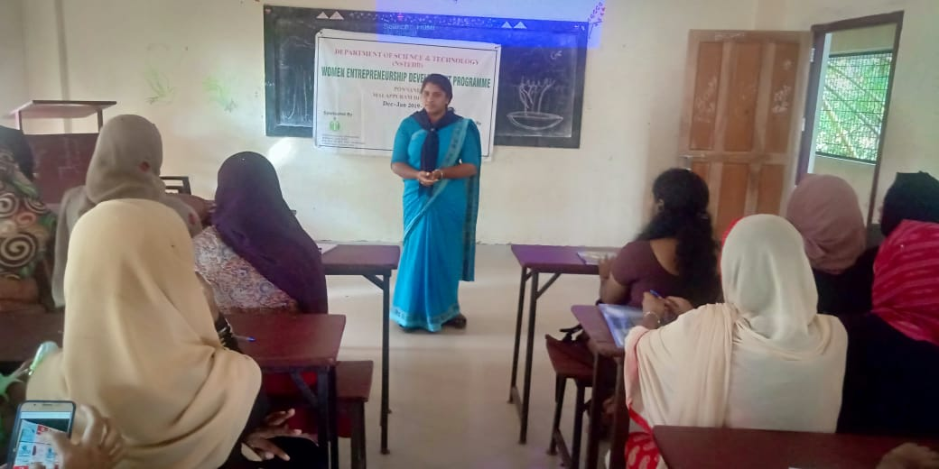

16.12.2019

On 16th December 2019, class taken by Mrs. Shereefa P P(Proprietor,Green farm,Parappanangadi). She explained some stories as an entrepreneur ,success and failure in various products and also what are the steps should be taken before enter into market.

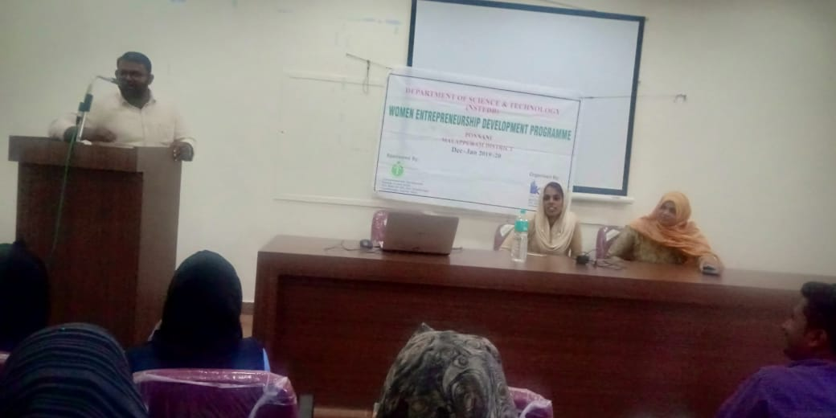

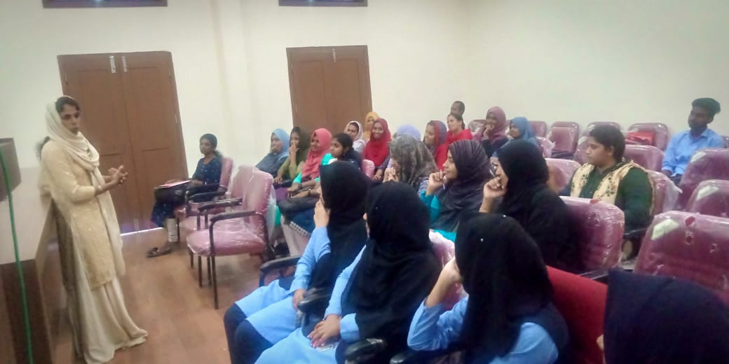

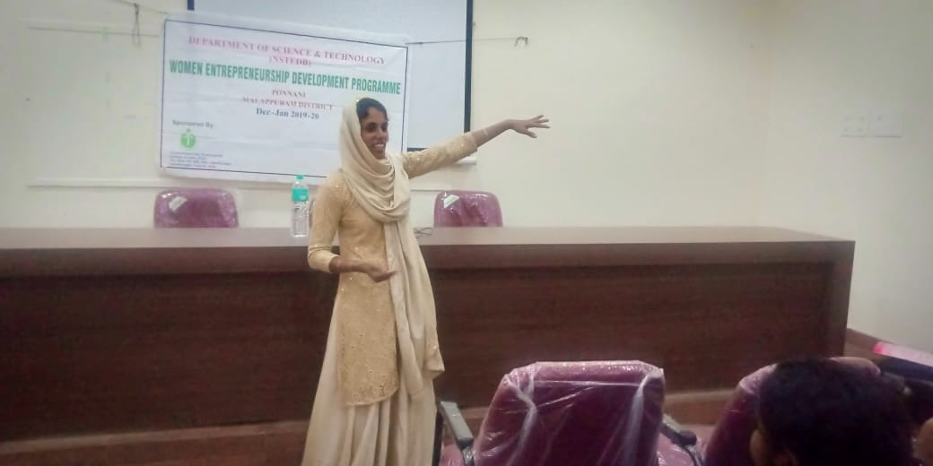

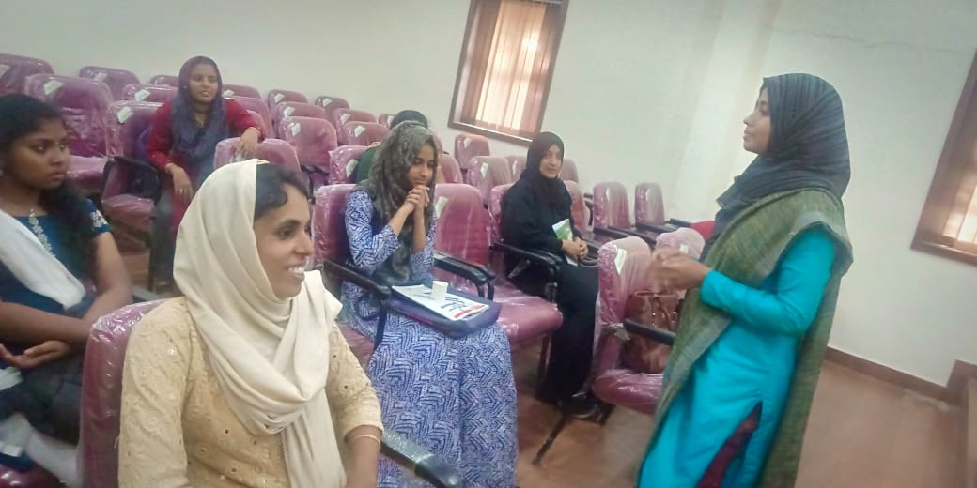

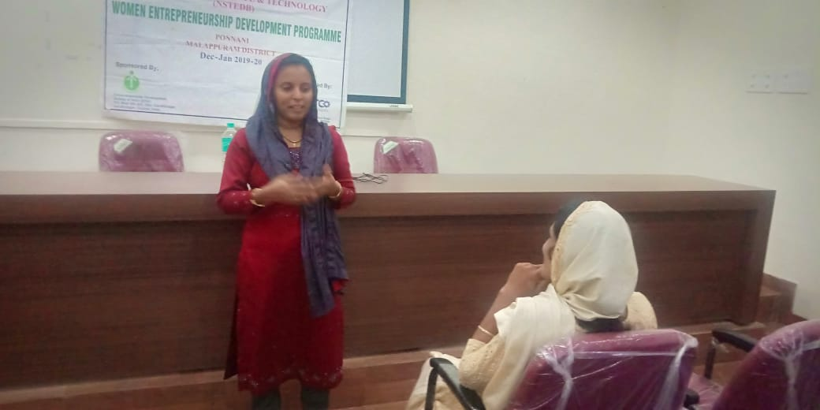

18.12.2019

On 18th December 2019, Class taken by Smt. Roshini C (Trainer,RUDSET Institute, Kanhangad) on the topic who is an entrepreneur, what is the difference between businessman and entrepreneur in detail. She well explained what are the skills to be needed for entrepreneur,how to find out the opportunities and persistence etc.

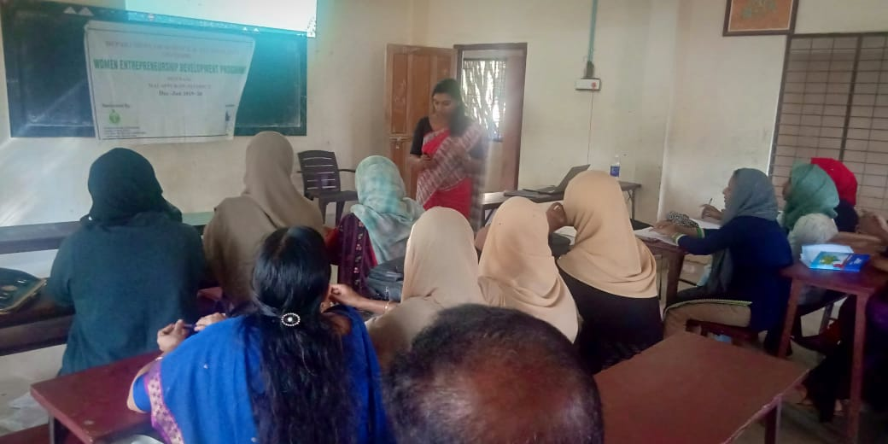

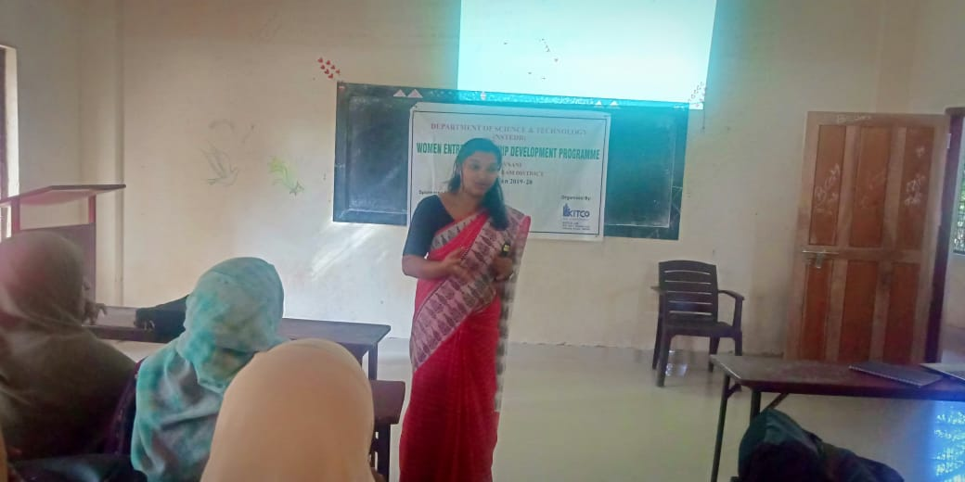

19.12.2019

Class taken by Sri Linto S Akkara(financial literacy councilor,Ponnani) &Sri T K Velayudhan(financial councilor,Malappuram) on the topic Bank loan formalities, assistance from other banks and institutions

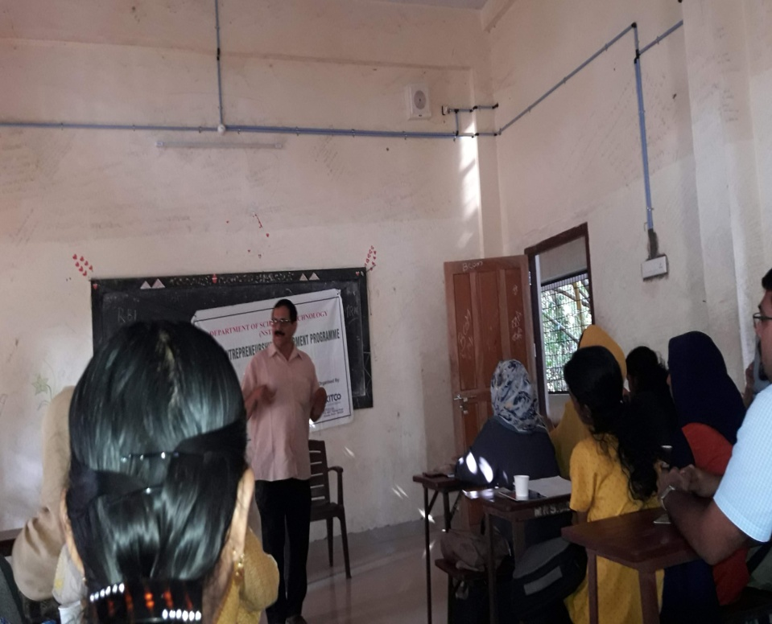

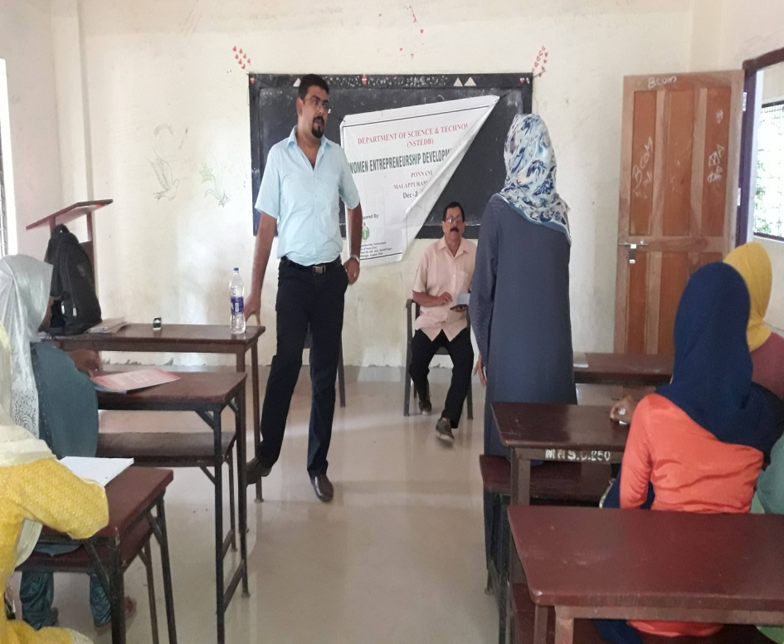

20.12.2019

On 20th December 2019, class taken by Sri Abhilash Narayanan(Trainer,RUDSET Institute,Kanhangad) on the topic customer care and customer communication.He explained different type of customers, business closing, customer retension management.

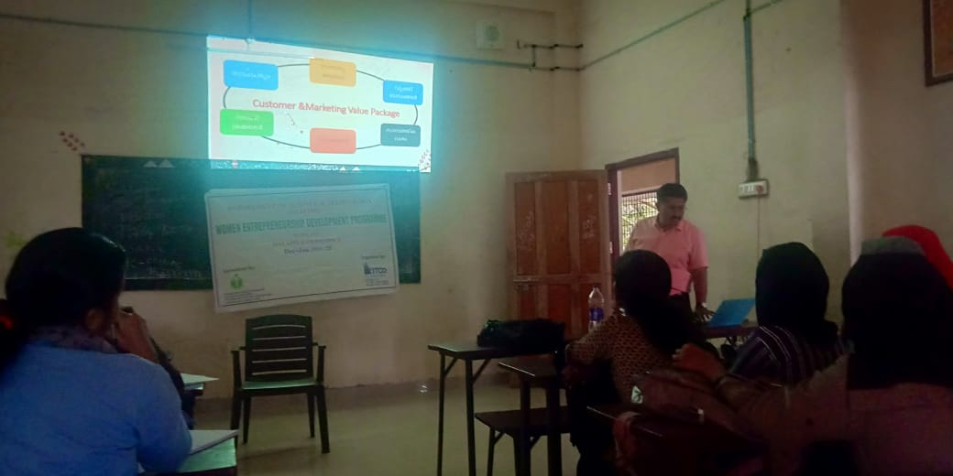

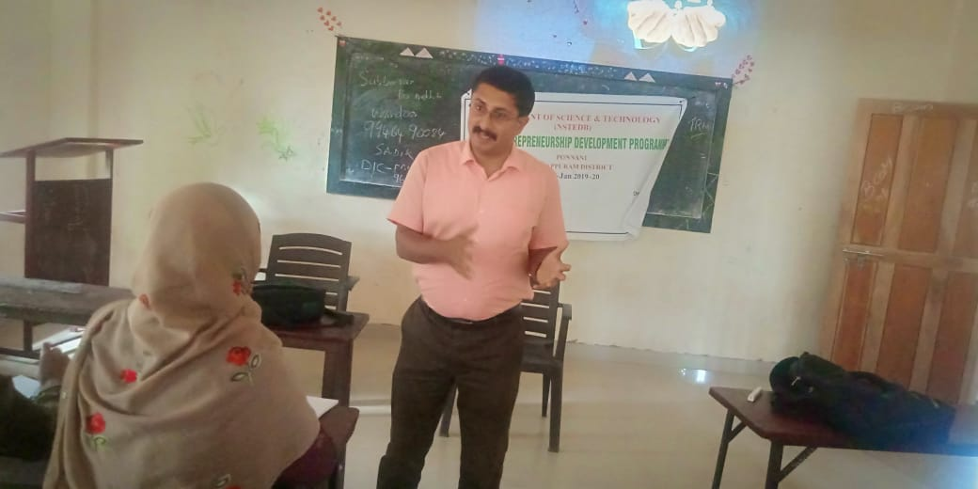

30.12.2019

Class taken by Abdul latheef (expert in digital marketing in Edappal) on the topic digital marketing. Digital marketing inbound(twitter,you tube, facebook etc) and out bound (google strategy,pitfall case study)

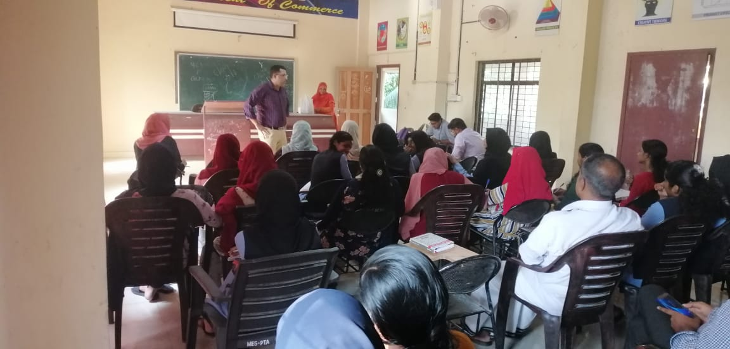

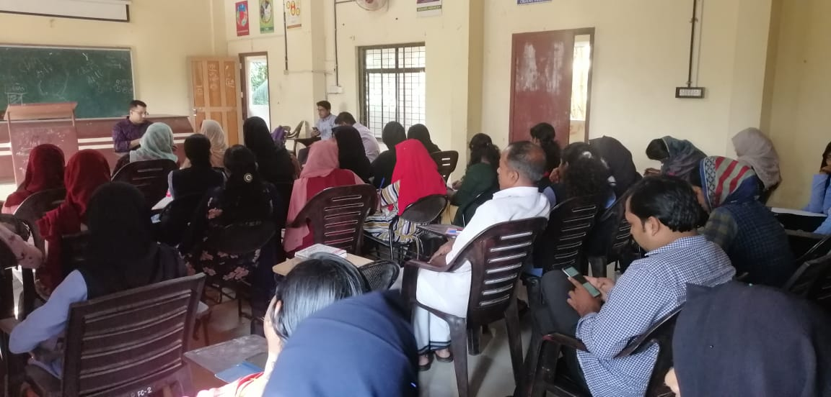

31.12.2019

Class taken by Dr Rajesh E K, (Assistant Professor, KCAET,Kerala Agricultural University )on the topic project identification on food processing , Fruits and vegetables

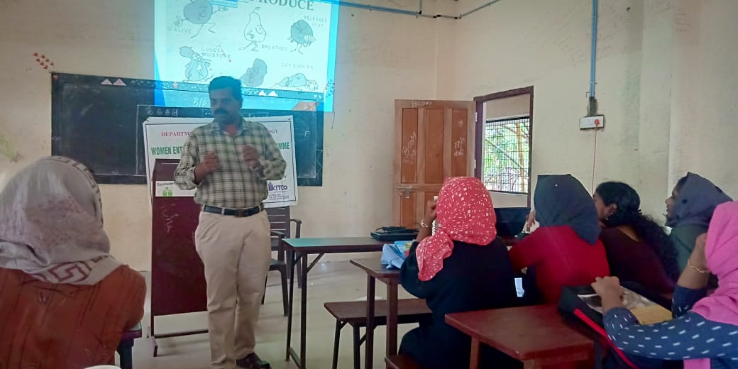

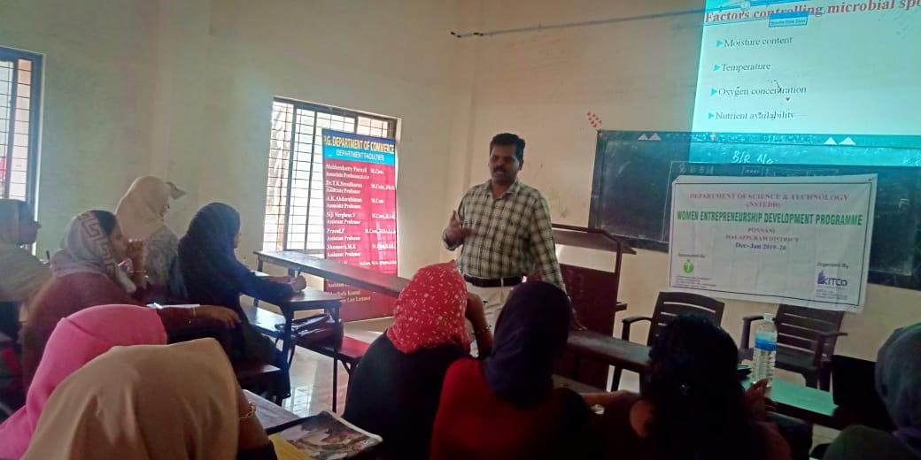

1.01.2020

Class taken by Dr. Sreenivasan O V (Trainer,Retd,Industrial Extension Officer,DIC,Kannur) on the topic project preparation This class was mainly how to prepare a project,parts of project,purpose etc.Parts of project include

1. Introduction 2. Location 3. Market potential 4. Balance sheet 5. Statement of term loan repayment and interest on loan

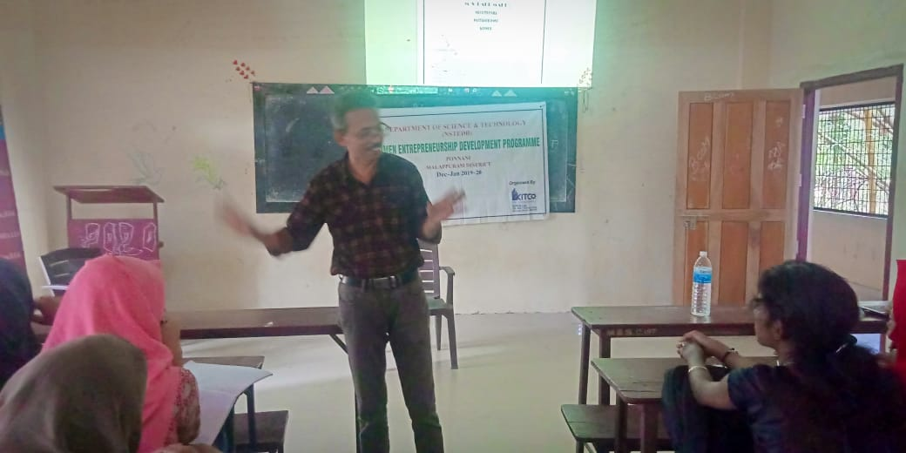

3.01.2020

Class taken by Smt. Mukthi Sumangala.(Assistant Professor, Fashion management studies ,NIFT, Kannur) The topic was project identification on ready made garements. In addition to the above topic she dealt with various facts such as social and economic survey,observation, identify the gap,pricing,idea generation which are more important for entering into new business. We done the activity based on the business model canvas by grouping us.

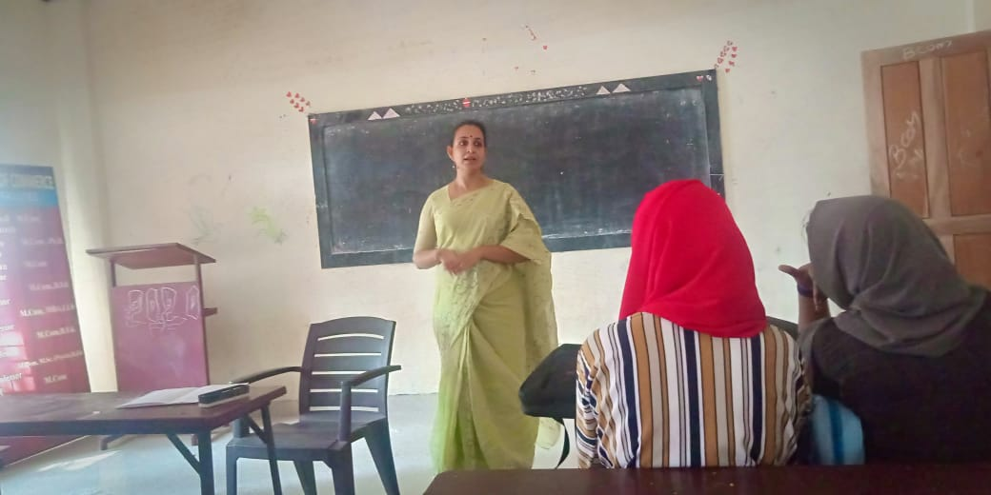

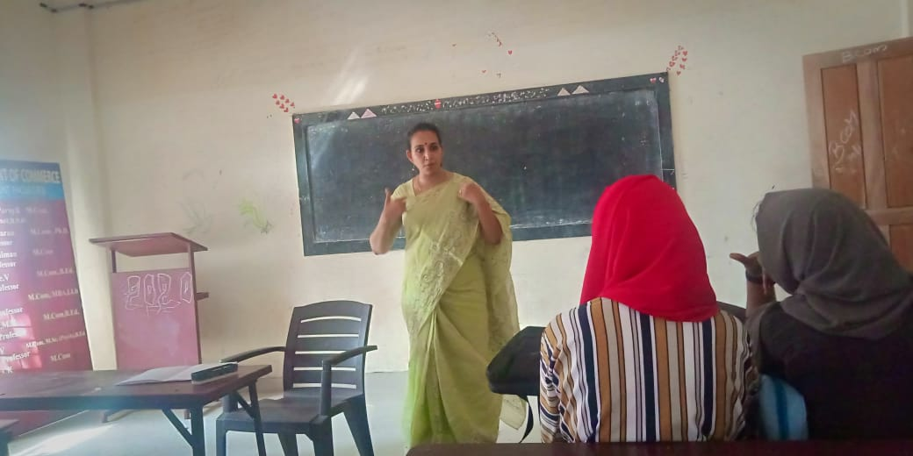

6.01.2020

Class taken by Dr Raju Mathew (HOD,Devagiri institute of mgt and studies, kozhikode)on the topic Book Keeping and accountancy The class was very informative . He covered various sub topics such as journal.ledger,cash book,sales book, purchase book,balance sheet and also the importance of book keeping aaccounting .

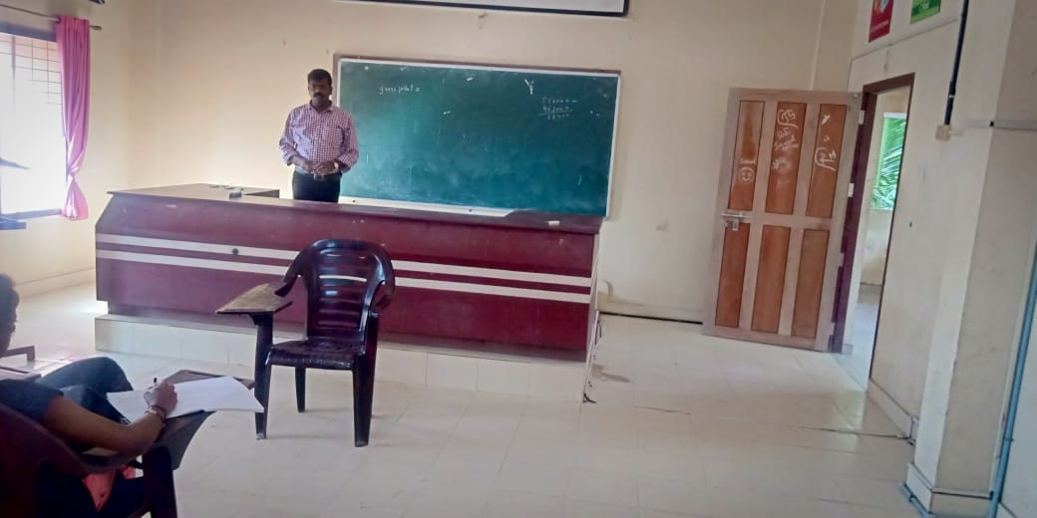

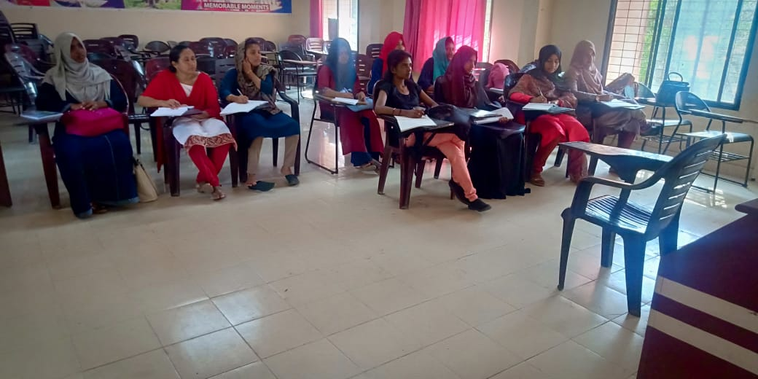

7.01.2020

Class taken by Dr Sreenivasan. His class mainly emphasized upon behavior of consumer. An entrepreneur must be extroverted personality. Before enter into the market one must know market survey , sentiments and demographic features etc.

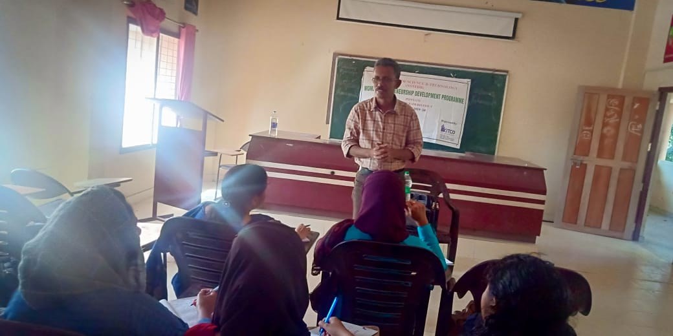

9.01.2020

he class was taken by Sri Hareesh K V(Faculty member,RUDSET, Kannur). The subject was Business management and needs of market survey before releasing the products.The product should be budget oriented.

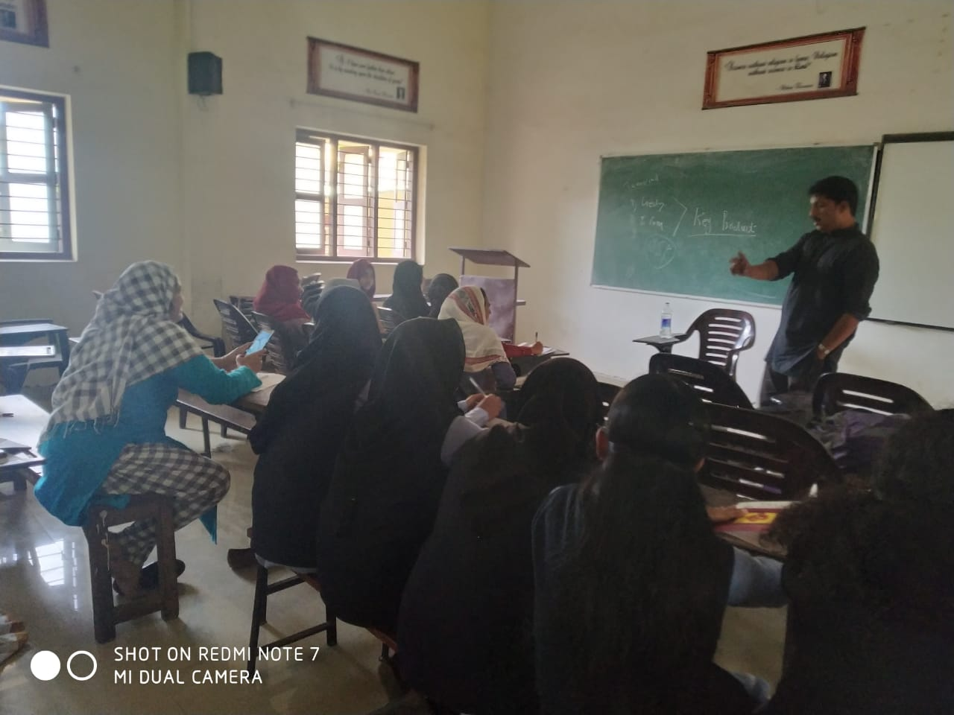

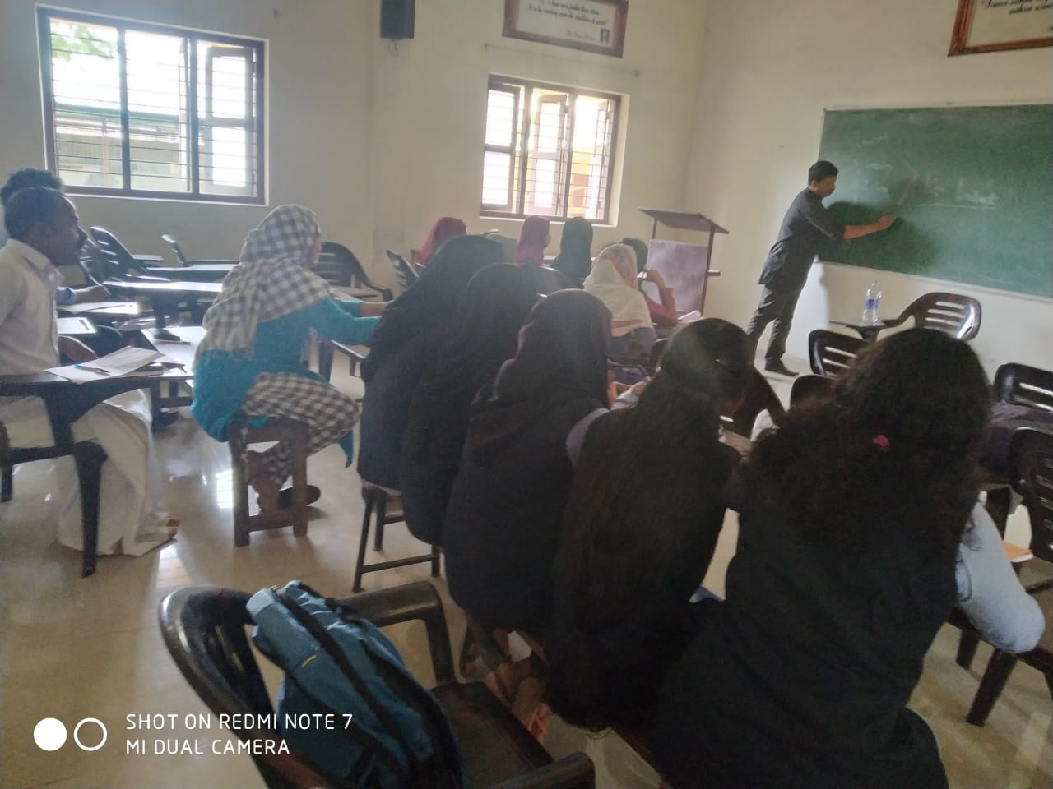

10.01.2020

Class taken by Sri Raju Mathew on the topic financial management of an entrepreneur and how to analyse BEP. The topic includes CVP Anaysis, Trade Dipression etc

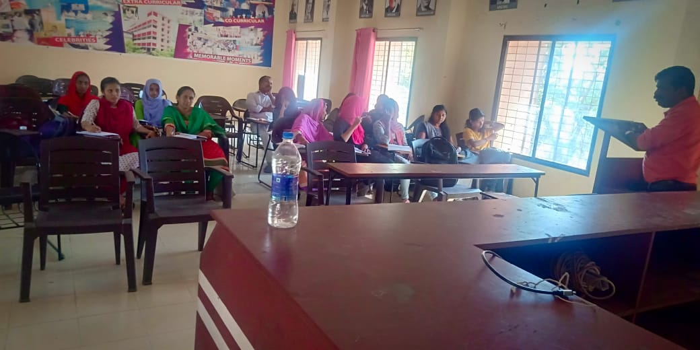

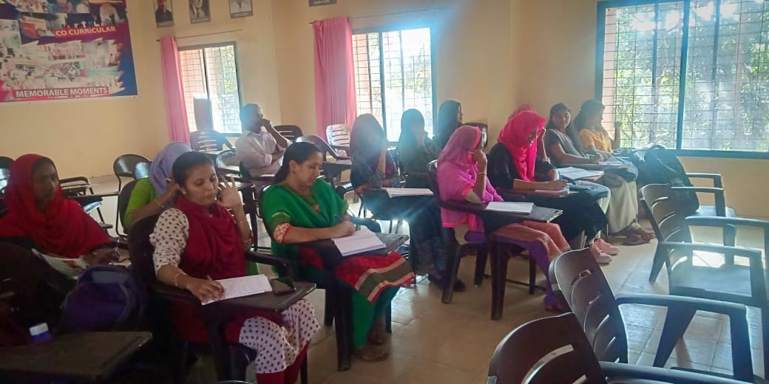

13.01.2020

This session lead by Sri Anand E J (Senior Librarian,Retd,Kitco).Subject project identification in the present scenario.The topic covers opportunity identification, criteria of selection& sources of information.

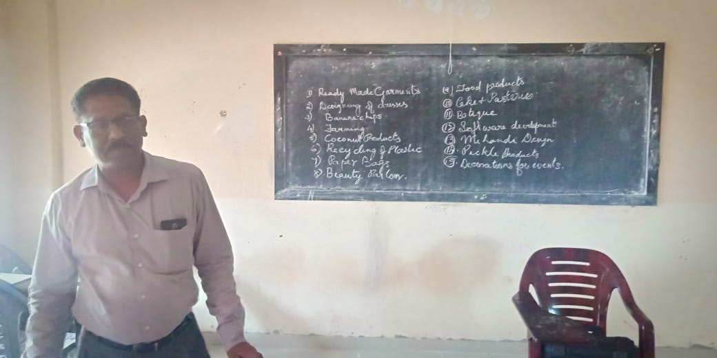

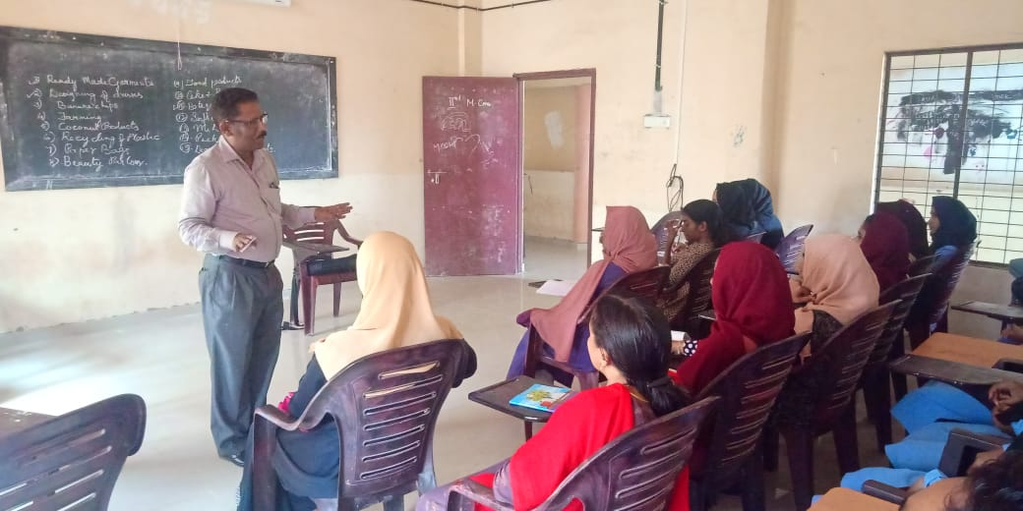

15.01.2020

Industrial visit was coordinated by Sri Dileepkumar K. We started journey from MES Ponnani College at 9.30 am and reached Kakkanchery at 12.30 pm. In Kinfra park we visited MerryBoy Ice cream production unit and Polyflex plastic bag production unit. After lunch we went to edappal garment production unit.

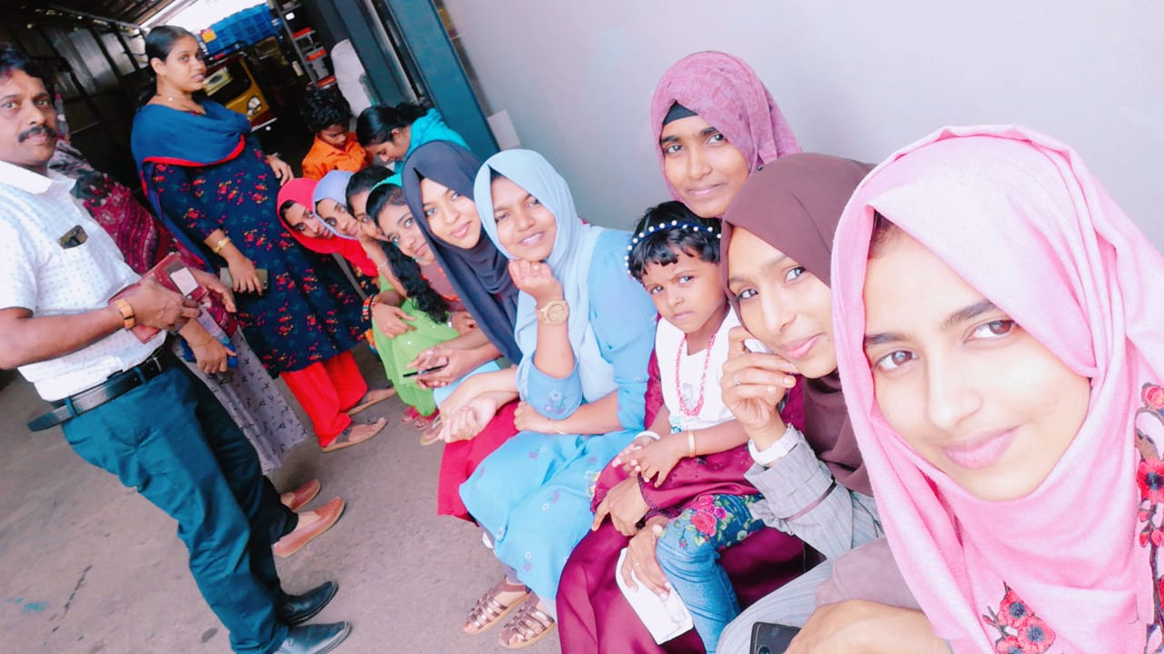

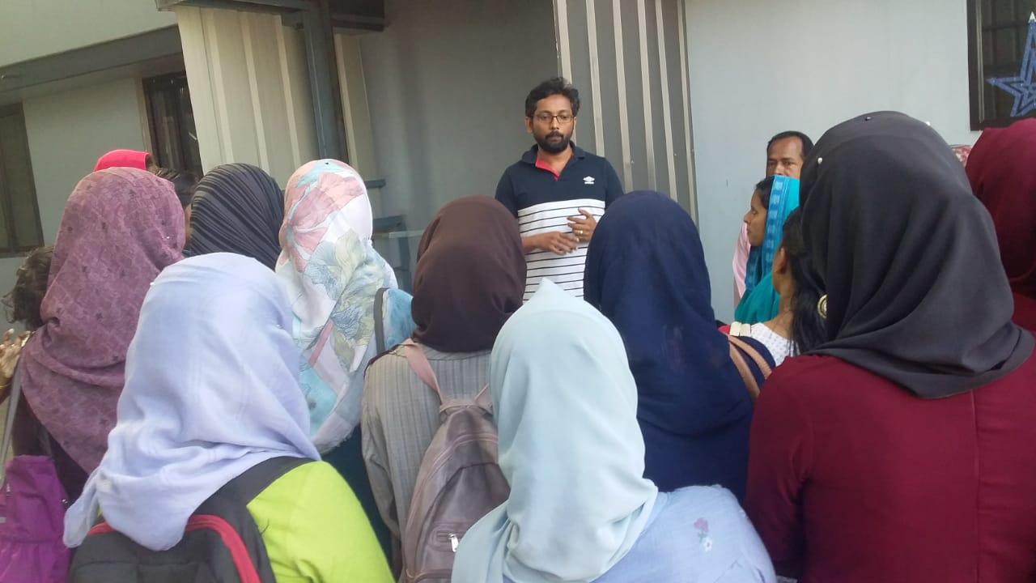

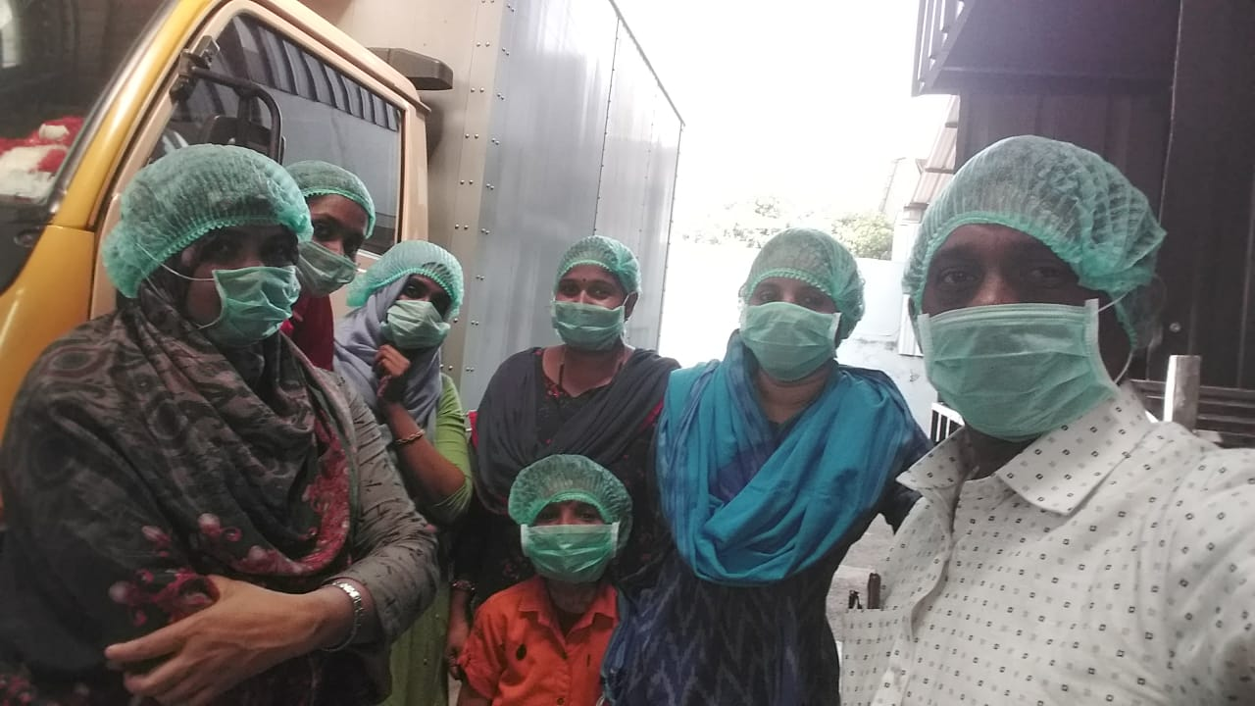

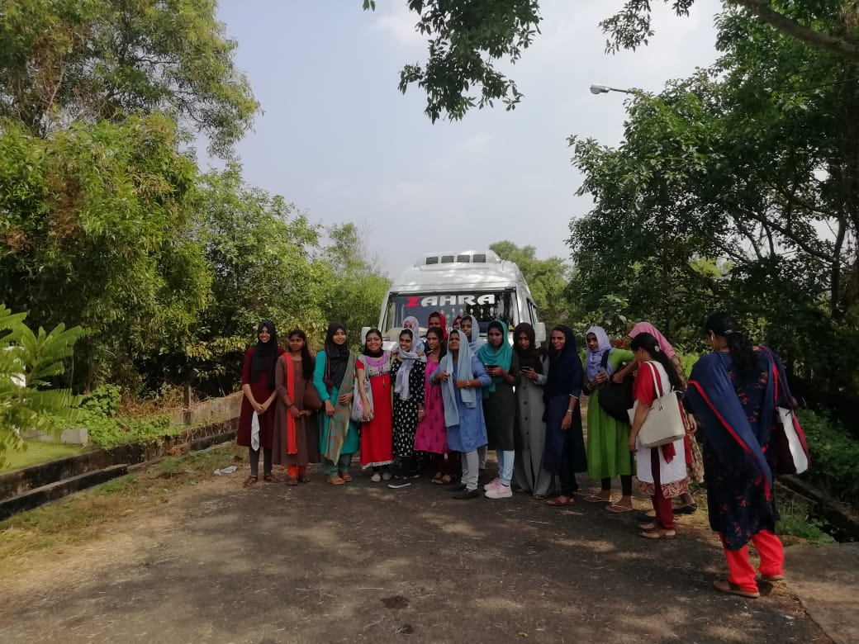

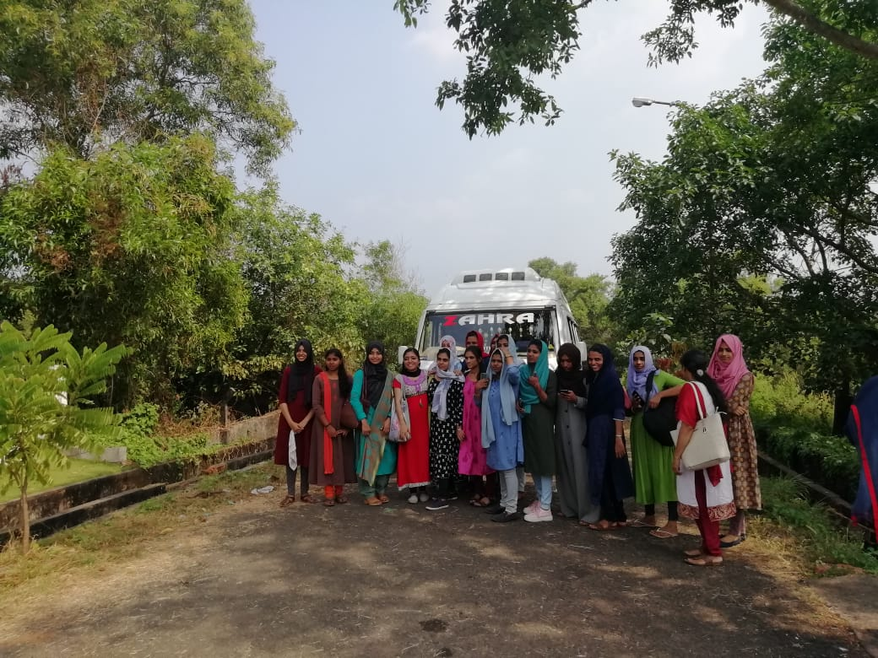

16.01.2020

At 1.30 pm class wastaken by Sri K Unnikrishnan (Retd. Principal consultant Kitco). his topic was business planning

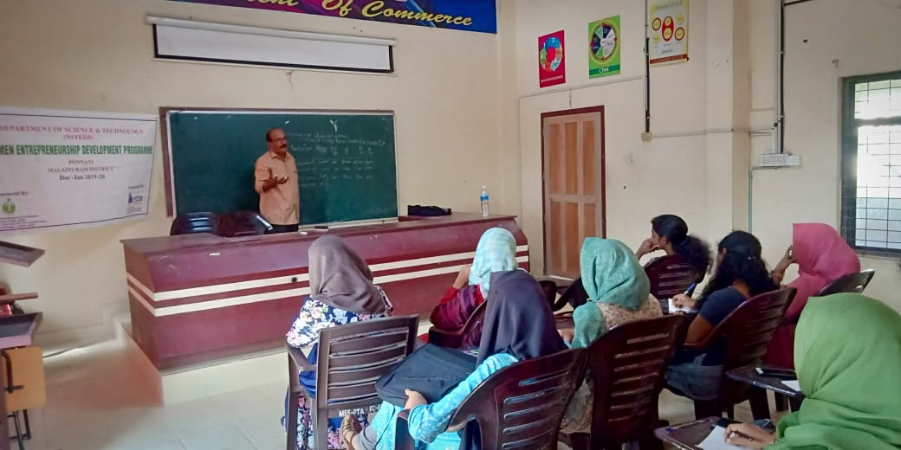

That day at 3.30 pm WEDP valedictory session started. The Principal , MES Ponnani College inaugurated the function. Sri jahfar A delivered welcome speech. Sri Dileep kumar K Kitco coordinator delivered the key note address. Smt Siji Verghese HOD, Department of Commerce presided over the function. Felicitation given by Dr Sina A R Secretary,staff club and college union vice chair person. Vote of thanks delivered by Smt Muneera k coordinator ED club. In this function honoring coordinators Sri Dileep Kumar K and Smt Nisha ponnani coordinator giving mementos. The certificates distributed to all WEDP members. The course evaluated by three members Dr Sulaiha, Najla engineer and sumayya . They opined that The programme was given to them good experience .

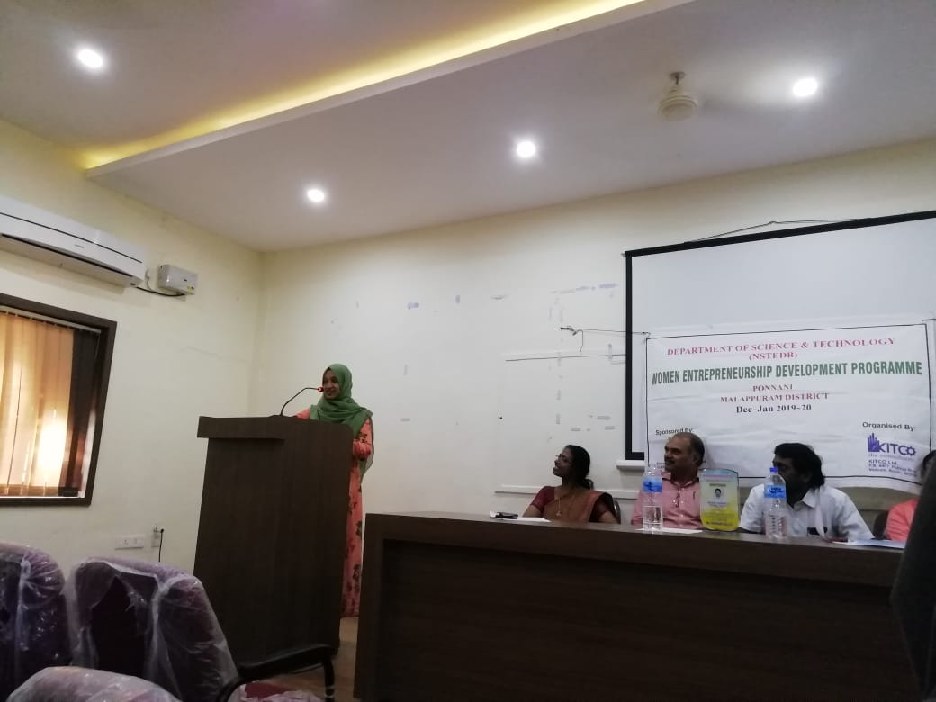

Programme evaluation by Najeela

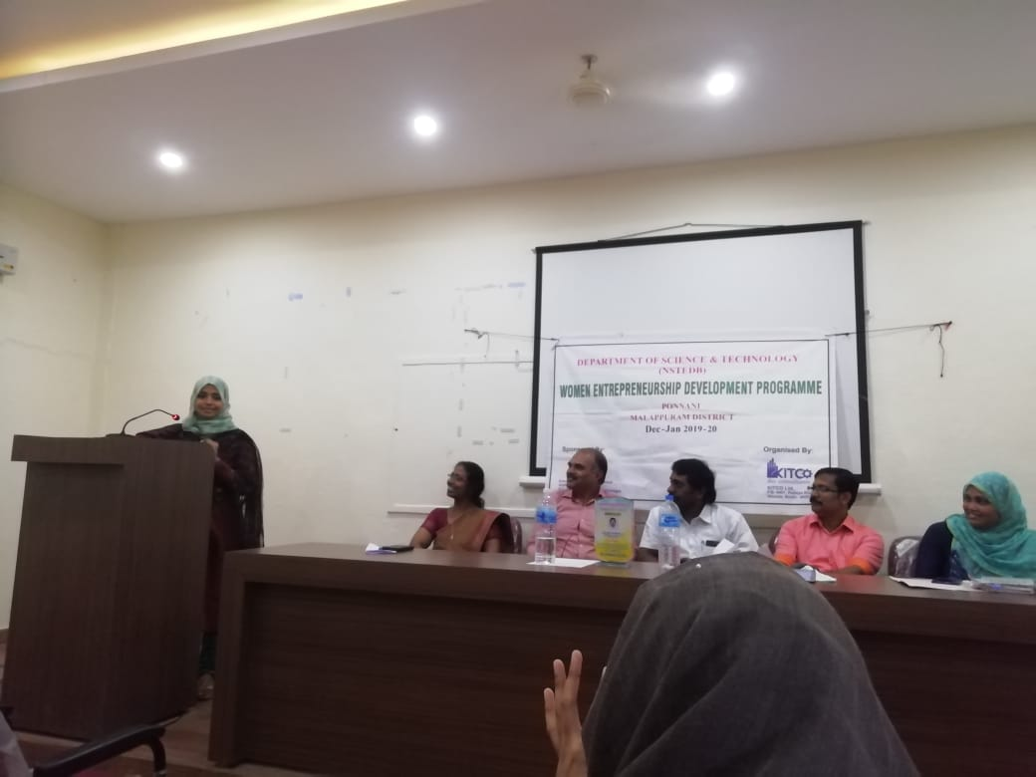

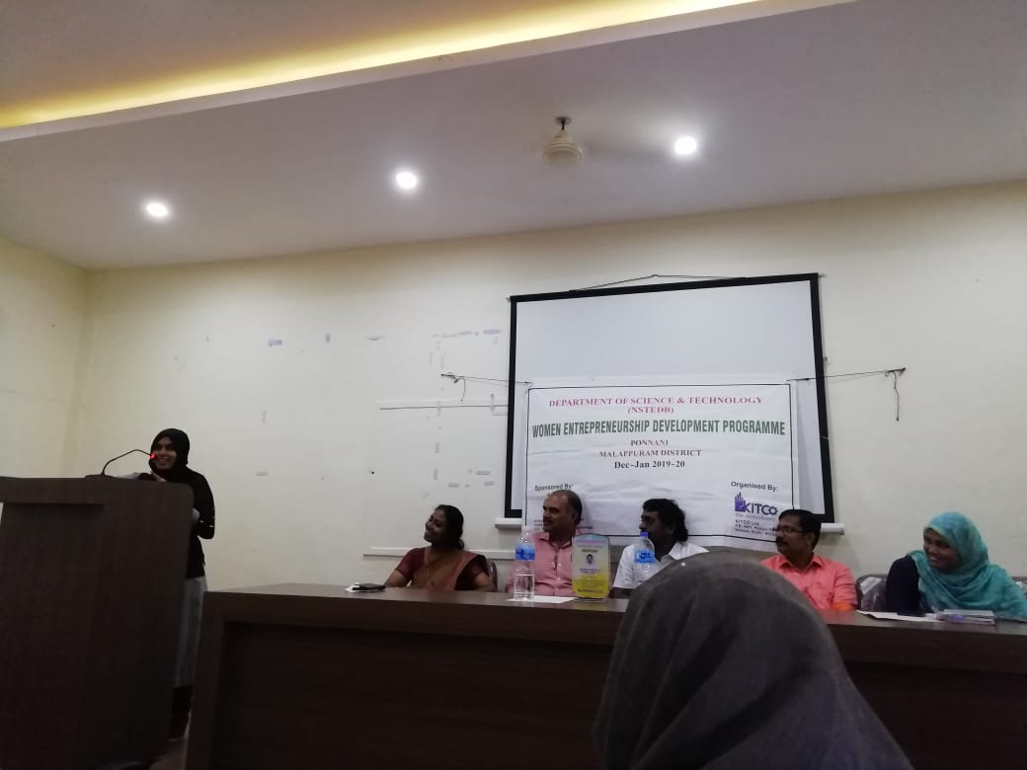

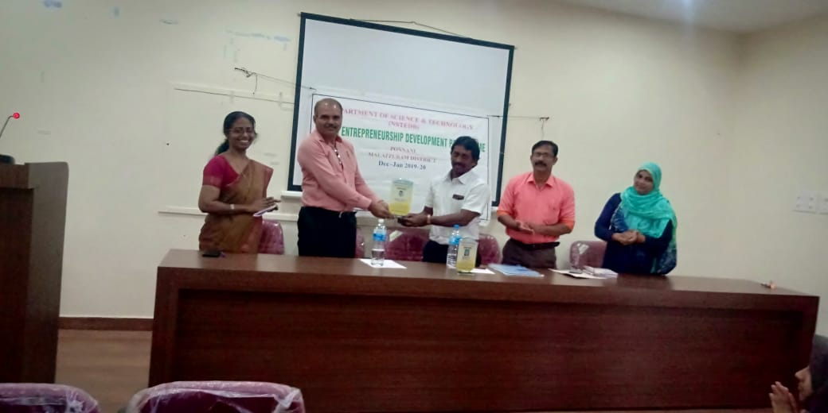

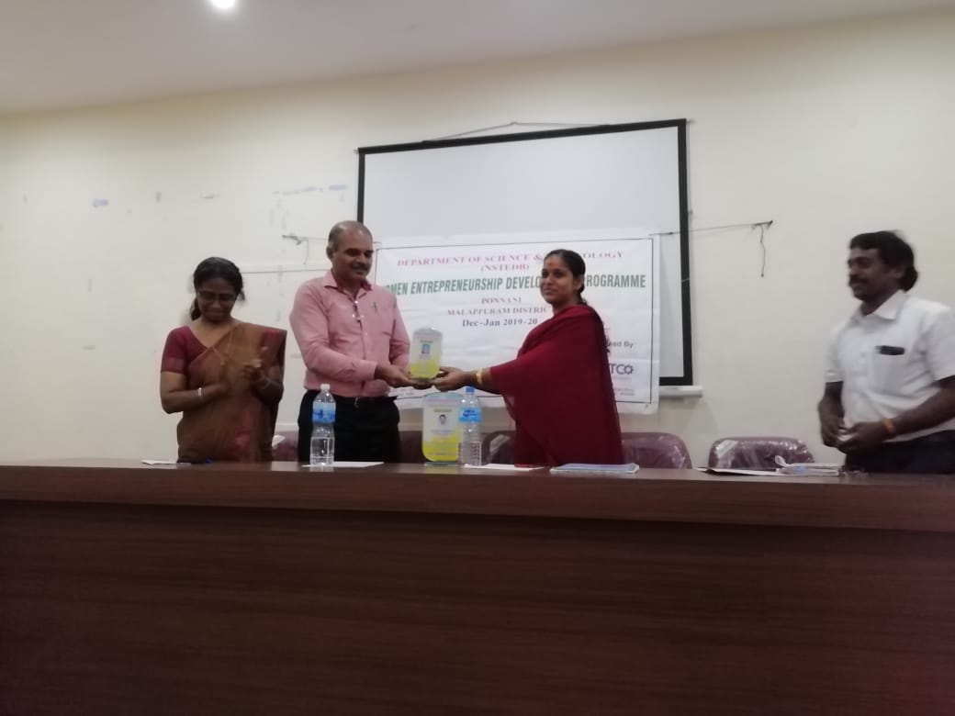

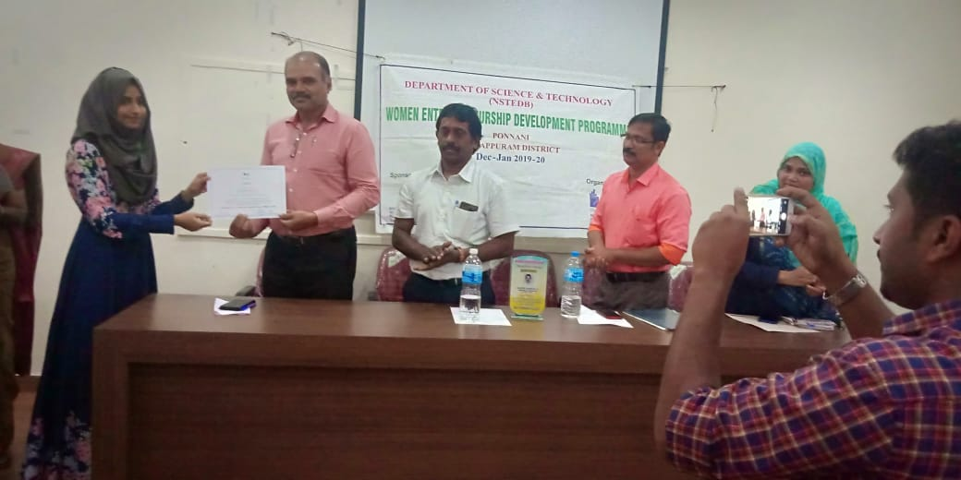

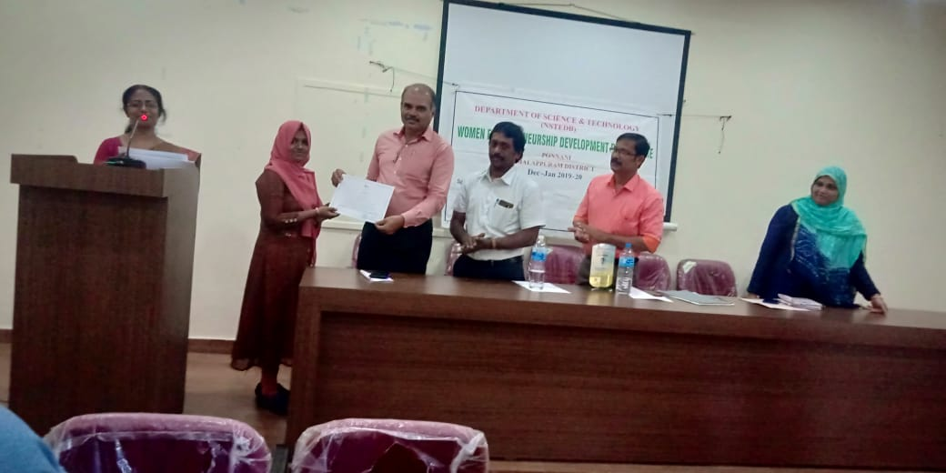

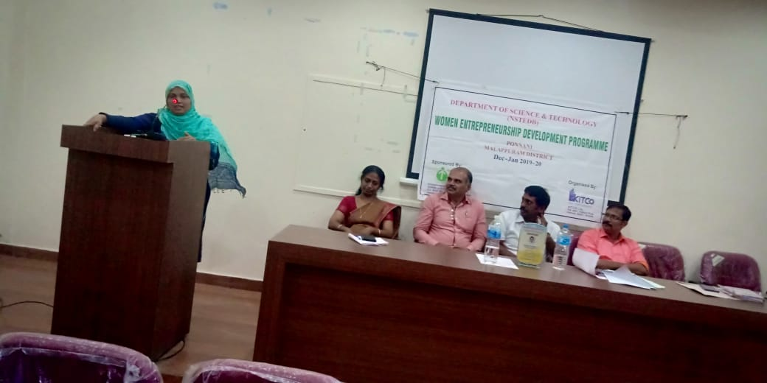

The programme became grant success because of our wedp members engineer Najla and Dr Suhaira participated “IDEATHON” start up program organized by Tirur Block Panchayath on February 4th 2020 in Imbichi bava hospital ,Alathiyur. Around 49 teams participated. 10 teams selected. Out of 10 , one team Dr suhaira and Najla. They presented the project.

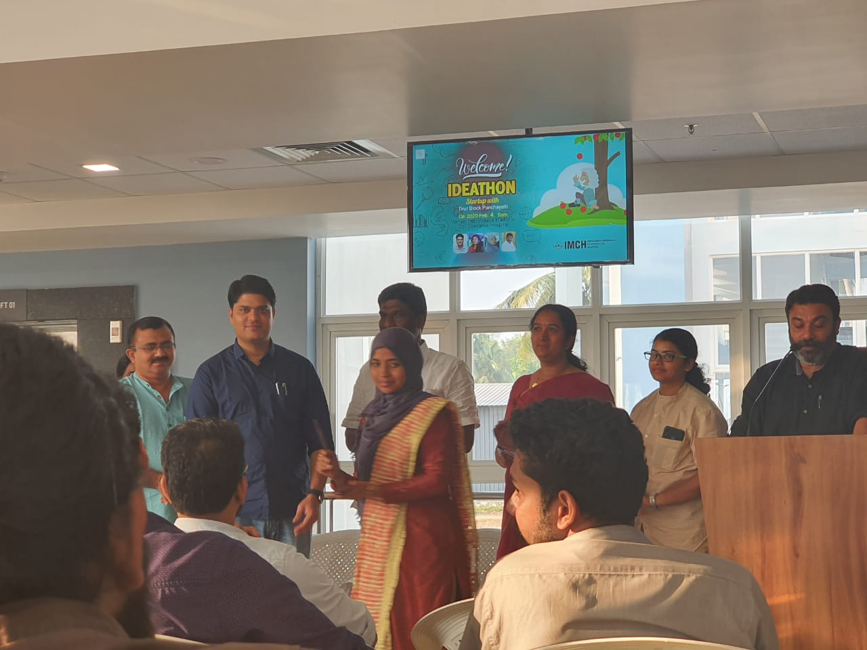

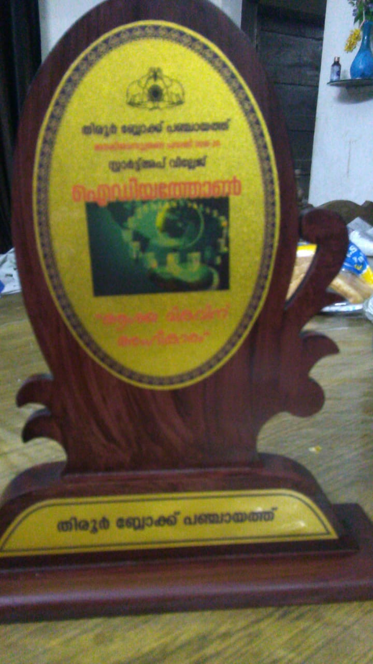

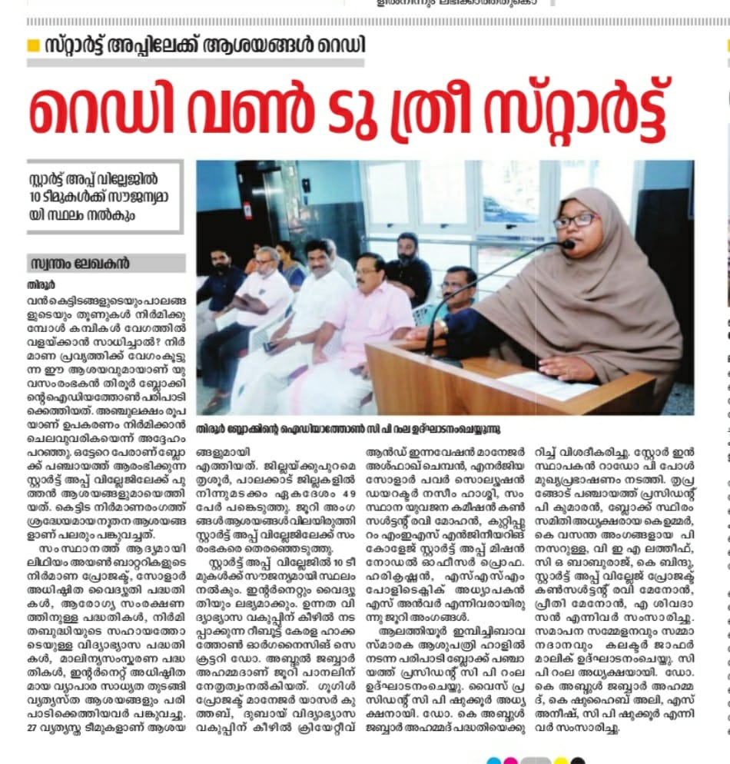

28-01-2020

Sharoof T K, Arjun, Ansar K, Rashad & Shahul Hameed (2nd B com) participated the program ‘interact with successful entrepreneurs’ organized by Malabar Chamber of Commerce on 28th January 2020 at Soorya Regency, Malappuram. They had good experience.

